

CALAVERAS COUNTY

SUPERIOR COURT

LOCAL COURT RULES

EFFECTIVE: JULY 1, 2025

“This page left intentionally blank”

TABLE OF CONTENTS
LOCAL RULES FOR THE SUPERIOR COURT
COUNTY OF CALAVERAS COURT
EFFECTIVE JULY 1, 2025

CHAPTER 1 – PRELIMINARY RULES 1
1.1 Scope of Rules (Eff. 7/1/98; As amended, eff. 1/1/01.) 1
1.2 Citation of Rules (Eff. 7/1/98; As amended, eff. 1/1/01.) 1
1.3 Effective Date of Rules (Eff. 7/1/98; As amended, eff. 1/1/19.) 1
1.4 Effect of Rules (Eff. 7/1/98; As amended, eff. 1/1/02.) 1
1.5 Construction and Application of Rules (Eff. 7/1/98; As amended, eff. 1/1/01.) 1
1.6 State Rules and Corresponding Local Rules (Eff. 7/1/98; As amended, eff. 1/1/01.) 1
1.7 Amendment, Addition or Repeal of these Rules - Sanctions for Failure to Comply with Rules (Eff. 7/1/98; As amended, eff. 1/1/01.) 1
CHAPTER 2 – GENERAL RULES 3
2.1 Filing and Format of Documents (Eff. 7/1/98; As amended, eff. 7/1/19.) 3
2.2 Facsimile Filings (Eff. 1/1/08; As amended eff. 1/1/17.) 3
2.3 Application for Waiver of Court Fees and Costs (Eff. 7/1/04; As amended eff. 1/1/08.) 3
2.4 Ex Parte or Informal Communication with the Court (Eff. 1/1/02; As amended, eff. 1/1/18.) 4
2.5 Sealed / Confidential Records (Eff. 1/1/02; As amended, eff. 7/1/19.) 5
2.6 Court Interpreters (Eff. 7/1/03; As amended, eff. 7/1/19.) 5
2.7 Official Reporting Services (Eff. 7/1/98; As amended, eff. 1/1/19.) 6
2.8 Calendaring Requests (Eff. 7/1/03; As amended, eff. 7/1/10.) 6
2.9 Appearance for Another Attorney (Eff. 7/1/98; As amended, eff. 7/1/02.) 6
2.10 Compensation of Appointed Counsel (Eff. 1/1/06) 7
2.11 Audio/Visual and Other Equipment for Demonstrative Evidence (Eff. 7/1/06) 7
2.12 Bulky and Hazardous Exhibits (Eff. 1/1/04; As amended, eff. 7/1/19.) 7
2.13 Coordination of Personal Conduct Orders (Eff. 1/1/04; As amended, eff. 7/1/09.) 8
2.14 Photographing, Recording, or Broadcasting in Court (Eff. 1/1/09; As amended, eff. 7/1/19.) 9
2.15 Electronic Filing (Eff. 1/1/18); As amended, eff. 1/1/20) 10
2.16 Attorney Conduct 11
2.17 Appointment of Elisor (Eff. 1/1/24) …………………………………….…………….………..11
CHAPTER 3- CIVIL RULES 13
3.1 Ex Parte Applications (Eff. 7/1/98; As amended, eff. 1/1/18.) 13
3.2 Proof Of Service of Summons (Eff. 7/1/98; As amended, eff. 7/1/09.) 14
3.3 Law and Motion (Eff. 1/1/04; As amended, eff. 1/1/18.) 14
3.3.1 Motion to be Relieved as Counsel (Eff. 7/1/98; As amended, eff. 1/1/08.) 15
3.3.2 Default Judgments by Affidavit (Eff. 7/1/98; As amended, 1/1/08.) 15
3.3.3 Attorney’s Fees on Default Judgments (Eff. 1/1/01.) 15
3.3.4 Orders After Hearing (Eff. 7/1/98; As amended, eff. 1/1/08.) 15
3.3.5 Continuances on Short Cause Law and Motion and Order to Show Cause Calendar (Eff. 7/1/98; As amended, eff. 1/1/01.) 16
3.3.6 Lack of Appearance (Eff. 7/1/98; As amended, eff. 7/1/05.) 16
3.3.7 Tentative Rulings (Repealed Eff. 7/1/06; As amended 1/1/18) 16
3.4 Civil Delay Reductions Rules 16
3.4.1 Scope and Policy (Eff. 7/1/98; As amended, eff. 1/1/01.) 16
3.4.2 Definition of General Civil Case (Eff. 7/1/98; As amended, eff. 7/1/02.) 17
3.4.3 Initial Contact (Eff. 7/1/98; As amended, eff. 1/1/01.) 17
3.4.4 Cross-Complaints (Eff. 7/1/98; As amended, eff. 7/1/02.) 17
3.4.5 Case Management Conference (Eff. 7/1/98; As amended, eff. 1/1/08.) 17
3.4.6 Differentiation of Cases to Achieve Goals (Eff. 7/1/98; As amended, eff. 1/1/08.) 18
3.4.7 Demand for Jury Trial (Eff. 7/1/98; As amended, eff. 7/1/04.) 18
3.4.8 Motions (Eff. 7/1/98.) 18
3.4.9 At-Issue Memorandum Abolished (Eff. 7/1/98.) 18
3.4.10 Sanctions (Eff. 7/1/98.) 19
3.5 Judicial Arbitration (Eff. 7/1/98; As amended, eff. 1/1/08.) 19
3.6 Settlement Conference 19
3.6.1 Requirement of Settlement Conference (Eff. 7/1/98; As amended, eff. 1/1/01.) 19
3.6.2 Each Party to be Prepared (Eff. 7/1/98; As amended, eff. 1/1/14.) 19
3.6.3 Settlement Conference Statement (Eff. 7/1/98; As amended, eff. 1/1/08.) 20
3.6.4 Participation in Good Faith (Eff. 7/1/98.) 20
3.6.5 Failure to Appear (Eff. 7/1/98; As amended, eff. 7/1/04.) 20
3.7 Unlawful Detainer Settings (Eff. 1/1/09; As amended, eff. 7/1/09.) 21
3.7.1 Unlawful Detainer Trials (Eff. 1/1/18) 21
3.8 Telephone Appearances (Eff. 1/1/02; As Amended eff. 1/1/19.) 21
3.9 Civil Mediation Program (Eff. 7/1/06; Repealed 1/11/11.) 22
CHAPTER 4- CRIMINAL RULES 23
4.1 Witness Lists (Eff. 7/1/98.) 23
4.2 Continuances (Eff. 1/1/01; As amended, eff. 1/1/02.) 23
4.3 Pleas at the Time of Trial (Eff. 1/1/01.) 23
4.4 Plea Bargaining (Eff. 1/1/02.) 23
4.5 Discovery (Eff. 1/1/02.) 23
4.6 Motions for Bail Modifications or Release on Own Recognizance (Eff. 1/1/02.) 23
4.7 Traffic Infractions – Trial by Declaration (Eff. 1/1/02; As amended, eff. 7/1/05.) 24
4.8 Fees for Investigators and Experts (Eff. 7/1/02; As amended, eff.7/1/12.) 24
4.9 Real Property Bonds in Lieu of Cash Bail (Eff. 7/1/04 As amended, eff. 1/1/11.) 25
4.10 Continuance of Infraction Trials (Eff. 1/1/13; As amended, eff. 1/1/17.) 27
4.11 Misdemeanors and Infractions (Eff. 1/1/19.) 27
4.12 Mandatory Trial Readiness Conferences (Eff. 1/1/20) 26
4.13 Exhibits (Eff. 1/1/20) 26
CHAPTER 5- FAMILY LAW and JUVENILE RULES 28
5.1 Matters Heard (Eff. 7/1/98; As amended, eff. 1/1/14.) 28
5.2 Setting Family Law Motion Hearings (Eff. 1/1/03; As amended, eff. 1/1/18.) 28
5.3 Service of Notice / Pleadings of Family Law Motion Hearings (Eff. 1/1/14.) 30
5.4 Filing Family Law Motions with the Court (Eff. 1/1/03; As amended, eff. 1/1/14.) 30
5.5 Pre-Hearing Meet and Confer / Exchange of Documents (Eff. 1/1/03.) 31
5.6 Hearings on Family Law Motions (Eff. 1/1/03; As amended, eff. 1/1/14.) 31
5.7 Orders on Motions and Stipulations (Eff. 1/1/03.) 32
5.8 Trial (Eff. 1/1/03; As amended, eff. 1/1/09.) 32
5.8.1 Filing the At-issue Memorandum (Eff. 1/1/03; As amended, eff. 1/1/09) 32
5.8.2 Mandatory Settlement and Trial Setting Conference (Eff. 1/1/03; As amended, eff. 1/1/14.) 32
5.9 Family Law Caseflow Program (Eff. 7/1/02; As amended, eff. 1/1/25.) 33
5.10 Appointment of Counsel Pursuant to Family Code §3150 (Eff. 7/1/98; As amended, eff. 1/1/04.) 34
5.11 Child Custody Mediation (Eff. 1/1/03; As amended, eff. 1/1/14.) 35
5.12 Child Custody Evaluations. (Eff. 7/1/01; As amended, eff. 1/1/04.) 36
5.13 Family Law Facilitator (Eff. 1/1/02; As amended, eff. 1/1/06.) 37
5.14 Dismissal of Domestic Violence Orders or Actions (Eff. 7/1/10.) 37
5.15 Remote Appearances for Child Support (Eff. 7/1/24.) 37
5.16 Domestic Violence Restraining Order, Remote Appearance ………………………………………38

JUVENILE RULES 40
5.50 Appointment of Counsel in Juvenile Dependency Proceedings (Eff. 7/1/98; As amended, eff. 1/1/08.) 40
5.51 Juvenile Facsimile Filings (Eff. 1/1/01; As amended eff. 7/1/09.) 43
5.52 Authorization to Administer Psychotropic Medications (Eff. 7/1/01; As amended, eff. 1/1/08.) 43
5.53 Juvenile, Probate and Family Courts Exchange of Information (Eff. 7/1/02; As amended, eff 7/1/03.) 43
5.54 Court Appointed Special Advocate Program (CASA) (Eff. 07/01/17) 44
5.54.1 Adoption of Court Appointed Special Advocate Program (Eff. 07/01/17) 44
5.54.2 The CASA (Eff. 07/01/17) 44
5.54.3 Special Advocates (Eff. 07/01/17) 44
5.54.4 Release of Information to the Special Advocate (Eff. 07/01/17) 45
5.54.5 Right To Timely Notice (Eff. 07/01/17) 46
5.54.6 Calendar Priority (Eff. 07/01/17) 46
5.54.7 Visitation Through Dependency (Eff. 07/01/17) 46
5.54.8 Right to Appear (Eff. 07/01/17) 46
5.54.9 Distribution of CASA Reports (Eff. 07/01/17) 46
5.54.10 Distribution of CASA Reports (Eff. 07/01/17) 47
CHAPTER 6- GUN VIOLENCE 48
6.1 Gun Violence Restraining Orders…………………………………………………………………..47
CHAPTER 7- PROBATE RULES 50
7.1 Compensation for Guardians, Conservators, Trustees and their Counsel, and for Counsel for a Conservatee or Ward (Eff. 7/1/98.) 50
7.2 Claims of Minors and Incompetent Persons 50
7.2.1 Application for Appointment of Guardian Ad Litem (Eff. 7/1/98.) 50
7.2.2 Compromise of Claims and Attorney’s Fees (Eff. 1/1/02.) 51
7.2.3 Withdrawal of Funds (Eff. 7/1/98.) 52
7.3 Probate Petitions and Motion Calendar (Eff. 1/1/14; As amended eff. 1/1/18.) 50
CHAPTER 8 – APPELLATE RULES 54
8.1 Appellate Department Management (Eff. 7/1/98; As amended, eff. 7/1/09.) 54
8.2 Filing of Appeal, Briefing and Hearing Dates (Eff. 7/1/98.) 54
8.3 Clerk’s Transcript on Appeal (Eff. 7/1/02; As amended, eff. 1/1/09.) 54
8.4 Record in Appeals to the Appellate Department (Eff. 7/1/09; As amended, eff. 1/1/10.) 55
8.5 Briefing Procedure (Eff. 7/1/98.) 55
8.6 Prerogative Writs (Eff. 1/1/04.) 56
CHAPTER 9 – IS RESERVED 58
CHAPTER 10 – ADMINISTRATIVE MATTERS 59
10.1 Presiding Judge (Eff. 7/1/98; As amended, 7/1/12.) 59
10.2 Judicial Vacation Day Defined (Eff. 1/1/09.) 59
10.3 Court Executive Officer (Eff. 1/1/09; As amended, 1/1/17.) 59

APPENDIX A.

CURRENT LOCAL FORMS:
Alternative Dispute Resolution (ADR) Information (Eff. 6/30/01) – Optional
Application for Immediate Hearing (Eff. 1/1/08) – Mandatory
Application for Modification of Sentence (Infraction) (Eff. 9/1/14) – Optional
Declaration Regarding: Application for Order on Payment of Fee/Costs (Eff. 3/16/15) – Mandatory
Declaration – Ability to Pay Infraction Only
Exhibits: Application for Return/Receipt for Exhibits (Civil) – (Eff. 1/1/19) – Mandatory
Exhibits: Application for Return/Receipt for Exhibits (Criminal) (Eff. 1/1/19) – Mandatory
Exhibits: Application for Pick-Up/Return of Subpoena Duces Tecum (Eff. 1/1/19) – Mandatory
Exhibits: Notice and Order for Return/Destruction of Exhibits (Civil) (Eff. 1/1/19) – Mandatory
Exhibits: Notice and Order for Return/Destruction of Exhibits (Criminal) (Eff. 1/1/19) – Mandatory
Exhibits: Return Receipt for Subpoena Duces Tecum (Eff. 1/1/19) – Mandatory
Family Law Case Management (Eff. 1/1/08, Revised 7/1/25) – Optional
Juvenile Certificate of Competence (Eff. 1/1/05) – Mandatory
Notice of Motion and Motion to Continue Court Trial (Infraction) (Eff. 7/1/10) – Mandatory
Petition for Grandparent Visitation (Eff. 7/1/25) – Mandatory
Petition to have Felony Violation(s) Designated as Misdemeanor(s) (Eff. 7/1/25) – Optional
Request for Copy of Electronic Recording (Eff. 7/1/25) – Mandatory
Request to Set Default or Uncontested Matter for Hearing (Eff. 1/1/16) – Optional
Settlement Conference Statement (Eff. 7/1/25) – Optional
Stipulation and Order Referring Matter to Alternative Dispute Resolution (Eff. 7/1/14) – Optional
Trial Brief; Witness List; Exhibit List (Eff. 7/1/25) - Mandatory

INDEX ................................................................................................................................................... I-1

CHAPTER 1 – PRELIMINARY RULES

1.1 Scope of Rules (Eff. 7/1/98; As amended, eff. 1/1/01.)

These Local Rules of Court apply to the Calaveras County Superior Court.

1.2 Citation of Rules (Eff. 7/1/98; As amended, eff. 1/1/01.)

These Rules shall be known and cited as the “Local Rules for the Calaveras County
Superior Court.”

1.3 Effective Date of Rules (Eff. 7/1/98; As amended, eff. 1/1/19.)

These Rules shall take effect on January 1, 2019.

1.4 Effect of Rules (Eff. 7/1/98; As amended, eff. 1/1/02.)

These rules shall, on their effective date, supersede all local court rules previously adopted by the Calaveras County Superior Court.

1.5 Construction and Application of Rules (Eff. 7/1/98; As amended, eff. 1/1/01.)

These Rules shall be construed and applied in such a manner as not to conflict with the California Rules of Court and shall be liberally construed to facilitate and promote the business and administration of justice by the Calaveras County Superior Court.

1.6 State Rules and Corresponding Local Rules (Eff. 7/1/98; As amended, eff. 1/1/01.)

The California Rules of Court are not printed as part of the Calaveras County Local Rules but are considered incorporated within them. Proceedings in the Superior Court of Calaveras County are governed by the California Rules of Court as supplemented by these local rules. Each Local Rule must be read in conjunction with the California Rules of Court.

1.7 Amendment, Addition or Repeal of these Rules - Sanctions for Failure to

Comply with Rules (Eff. 7/1/98; As amended, eff. 1/1/01.)

These Local Rules may be adopted, amended or repealed by the majority vote of the judges of both courts at any judges’ meeting. Any rules adopted or amended shall be effective subject to the notice and publication requirements of the Code of Civil Procedure §575.1 and the requirements of Government Code §68071.

These Rules, where applicable to civil actions and proceedings and as amended from time to time, are adopted pursuant to Code of Civil Procedure §575.1. Any counsel, party represented by counsel, or party appearing in pro per, who fails to comply with any of the requirements set forth in these Rules shall, upon motion of a party or the court, be subject to the sanctions set forth in Code of Civil Procedure §575.2, Code of Civil Procedure
§177.5 and California Rules of Court, Rule 2.30.

CHAPTER 2 – GENERAL RULES

2.1 Filing and Format of Documents (Eff. 7/1/98; As amended, eff. 7/1/19.)

- All papers submitted for filing shall conform to the California Rules of Court, Rule 2.100 through 2.119. The clerk will endorse up to three copies of each document filed. It is recommended that all original signatures be in blue ink.

- Except where leave of court has been granted, the clerk shall not accept for filing any papers, documents, exhibits or dividers presented on pink or yellow paper.

- Documents may be submitted for filing as follows: by mail or filed in person at the clerk’s filing window, by use of the drop box or by e-Filing which is available on the Calaveras Superior Court website.

- Drop Box – A depository will be available for anyone seeking to file documents with the Court. The box will be accessible for document deposit until 4:00 p.m. on all court business days. Any document deposited in the drop box before 4:00 p.m. will be deemed filed on the date of deposit, provided they are appropriate for filing. Matters requiring immediate judicial attention such as restraining order requests should never be placed in the drop box. No person, other than an authorized court employee, is permitted to remove any item from the drop box. Conformed copies of a filing will not be returned via mail unless accompanied by a return envelope with adequate postage thereon.

2.2 Facsimile Filings (Eff. 1/1/08; As amended eff. 1/1/17.)

The Calaveras Superior Court accepts the filing of documents through a fax filing agency pursuant to California Rules of Court, Rule 2.303. The court does not accept the direct fax filing of documents pursuant to California Rules of Court, Rule 2.304 except upon exceptional circumstances and after obtaining leave of court.

2.3 Application for Waiver of Court Fees and Costs (Eff. 7/1/04; As amended eff. 1/1/08.)

- Initial Fees Waiver. Each party applying for a waiver of court fees / costs shall submit a separate application for each case. Failure to comply with this requirement, or failure to submit a complete and legible application will result in a denial of the application. The clerk is authorized to grant application for fee waivers that meet the standards of eligibility established by subdivision (a)(1)-(9) of the Government Code § 68632.

Additional Fees Waiver. In addition to the initial fee waiver above, application for waiver of the additional fees / costs referenced in Rule 3.56 of the California Rules of Court must be submitted on the Judicial Council form Application for Waiver of Additional Court Fees and Costs (FW-002) and must be submitted to the appropriate judge. If the relief sought is the waiver of jury fees, the application shall be made at least 25 days prior to the commencement of the trial for which the relief from fees imposed is sought, or at least five days in unlawful detainer proceedings.
- Recovery of Waived Fees and Costs. In all cases in which a prevailing party has been granted a waiver of fees/costs and is awarded costs, the court shall order that the party owing those costs pay the sum of all waived costs to the court.

- Reasonably Necessary Photocopying. The California Rules of Court authorize the court to waive the clerk's fees for reasonably necessary photocopying. This Court defines the papers which may be reasonably and necessarily photocopied at the court's expense under the fee waiver for the litigant benefited by the fee waiver as only one copy of those papers in the court's file for the action or proceeding in which the waiver of fees was granted, and excluding papers filed by the benefited litigant and/or papers not served upon the benefited litigant for the first five days following the date of filing.

- Termination of Waiver. The party requesting a waiver must immediately notify the court of any change in financial status that would affect the party’s ability to pay court fees/costs. Orders granting fees/costs waivers expire 60 days from the date of judgment.

2.4 Ex Parte or Informal Communication with the Court (Eff. 1/1/02; As amended, eff.

1/1/18.)

- The Court will not consider any ex parte communications from counsel or self-represented parties unless made in the manner prescribed by these Rules, by the California Rules of Court, or by the laws of this State. Except as permitted by law, lawyers and parties shall avoid ex parte communications on the substance of a pending case with a judicial officer or court research staff. Applications to the Court for an order or other relief should never be made by telephone call, letter, electronic mail, or facsimile. Letters or other communications between counsel or parties should not be sent to judicial officers or court research staff.

- Where applicable laws or rules permit an ex parte application or communication to the Court and there are no grounds for waiver of notice, the following duties apply: (1) Before making such application or communication, an attorney or self-represented party must make diligent efforts to notify all other parties; (2) The moving party must make reasonable efforts to accommodate the schedule of all other parties to permit all parties to appear either personally or through their legal representative; and (3) The moving party must avoid taking advantage of any other party’s known absence or unavailability. Counsel shall be mindful of Rules of Professional Conduct 5-300(b) concerning ex parte contact with the Court.

2.5 Sealed / Confidential Records (Eff. 1/1/02; As amended, eff. 7/1/09.)

Unless confidentiality is required by law, court records in both criminal and general civil cases are presumed to be open to the public for inspection. For all records filed where confidentiality is required by law, the document caption or title shall state “CONFIDENTIAL” with an accompanying citation to the applicable law requiring such confidentiality. An agreement or stipulation between the parties for confidentiality or sealing of a document filed with the court is legally insufficient. The law requires court findings prior to sealing any records. The party filing a “confidential” report shall, at the time of filing the document, submit an 8 ½ by 11 inch envelope with the document title, case number and the word “confidential” printed prominently on the outside. For any court record a party wishes to be “sealed” from public inspection, the party shall follow those procedures set out in California Rules of Court, Rule 2.551. The party requesting a record be sealed must submit a proposed order containing no confidential information as this order will be filed in the public portion of the file.

2.6 Court Interpreters (Eff. 7/1/03; As amended, eff. 7/1/19.)

- In all proceedings, including small claims, counsel or self-represented litigants requiring the assistance of a court interpreter for a non-English speaking party or witness at hearing or trial must make all necessary arrangements prior to the trial or hearing for the presence of an appropriate interpreter. The requesting party is required to file Judicial Council form Request for Interpreter (Civil) (INT-300). A request for an interpreter should be submitted once the requirement presents itself.

- To request an interpreter for a court proceeding complete Judicial Council form Request for Interpreter (Civil) (INT-300) or inform a Clerk at the counter. For Mediation, inform the clerk in the Self-Help Center.

- Counsel or the party must immediately notify the court upon learning that the services of the interpreter are not required. Failure to timely notify the court of the cancellation of the need for an interpreter may result in an order for reimbursement to the court for any cancellation fee the court is required to pay to the interpreter.

(d) If anyone has a complaint about language access services or desires to provide feedback about language access services, they may complete and submit local form Language Access Complaint Form.

2.7 Official Reporting Services (Eff. 7/1/98; As amended, eff. 1/1/19.)

- Court Reporter Availability – Services of an official court reporter are available as required by law in all felony and juvenile proceedings.

- Court Reporter in Other Proceedings - Pursuant to California Rule of Court 2.956(c) since the services of an official court reporter are not available for a hearing or trial in cases other than those referenced above in Local Rule 2.7(a), a party desiring a court reporter in any other matter must make arrangements for the presence of a court reporter and that party is responsible to pay all costs associated with the court reporter. There is an exception for in forma pauperis litigants who are granted a fee waiver for additional costs for court reporter.

- Electronic Recording as Official Record – Pursuant to Government Code §69957 and rules 2.952 and 2.954 of the California Rules of Court, the Court’s electronic recording system shall be the official reporting service for infractions and misdemeanors, and upon order of the Court in limited civil proceedings. For infraction and misdemeanor appeals where the appellant elects to proceed with a transcript of the oral proceedings instead of either a settled statement or a stipulation pursuant to rule 8.868(c) of the California Rules of Court to use the oral recording, the cost for preparation of the transcript shall be borne by the appellant.
- Payment for Reporter Services at Proceedings Lasting Less than One Hour - The fee for the services of the official court reporter for a proceeding of less than one hour is $30.00. The fee must be paid on or before hearing and the party requesting the services of the court reporter must provide proof of payment to the court reporter prior to commencement of the proceeding. (Government Code §68086(a).)

2.8 Calendaring Requests (Eff. 7/1/03; As amended, eff. 7/1/10.)

All requests to place matters on the court’s calendar for hearing, except traffic arraignments, must be made in writing and filed with the clerk.

2.9 Appearance for Another Attorney (Eff. 7/1/98; As amended, eff. 7/1/02.)

An attorney who appears for another attorney is representing the party then before the court. As provided by the California Rules of Professional Conduct, such attorney is required to do so competently and is expected to be prepared to carry out and perform any duties required by the court; to have authority to make appropriate dispositions or calendar settings and has the duty to communicate any orders the court may issue to the client and attorney of record.

2.10 Compensation of Appointed Counsel (Eff. 1/1/06)

For those proceedings in which the court appoints a lawyer to represent the interests of a party and the attorney has not entered into a contract for such services with the County or Court, the attorney shall be compensated at the rate set forth in the General Administrative Order Establishing Conflict Counsel Compensation. Upon application of court appointed counsel and for good cause shown the court may order a different compensation.

Requests by court appointed counsel for compensation should be submitted monthly and, in all cases, must be received by the court on or before ninety (90) days following the date the services were provided. Requests for compensation must be submitted on the court approved form available from the clerk’s filing window.

2.11 Audio/Visual and Other Equipment for Demonstrative Evidence (Eff. 7/1/06)

It is the responsibility of the parties to obtain, set up and operate all audio/visual and other equipment necessary to view or present any demonstrative evidence. Any such equipment proposed to be used in court shall be approved by the court in advance of set up and use.

2.12 Bulky and Hazardous Exhibits (Eff. 1/1/04; As amended, eff. 7/1/19.).)

- The Executive Officer/Clerk of the Calaveras County Court will not accept or retain exhibits that are bulky, heavy or designated as hazardous waste material.

- Pursuant to Penal Code §1417.3(b) and upon a finding of good cause, certain toxic materials may be brought into a courtroom and introduced into evidence provided they remain at all times in a sealed condition and properly labeled as to the exact contents thereof. Unless otherwise ordered by the court, the person bringing the evidence into the courtroom shall retain it and shall be responsible for the storage of the evidence and for the production and substitution of a photograph record in lieu of the evidence.

- In the event the court does not order the substitution of a photograph and/or technical report for the actual controlled substance evidence, the evidence shall be
stored by the person delivering it into the courtroom until it is eligible for destruction.

- Additional exhibits which are not to be sent to the courts' exhibits custodian, unless there is a court order for the court to retain them, include the following:
  - Any type of explosive powder.
  - Any explosive chemical such as toluene, ethane, etc.
  - Any explosive device such as a pipe bomb, hand grenade, etc.
  - Any flammable device such as a Molotov cocktail.
  - Any canister containing tear gas, mace, etc.
  - Any corrosive liquid.
  - Any rags soaked with any flammable liquid which are still damp or wet.
  - Dry P.C.P. in other than an airtight package, i.e., plastic.
  - Any liquid P.C.P.
  - Exhibits purporting to contain samples of blood, urine, human or animal fluids or tissues, or other items requiring refrigeration and/or humidity controlled storage.
  - All controlled substances as defined in §11007 of the California Health and Safety Code (which refers to schedules of controlled substances listed in H&S Sections 11054, 11055, 11056, 11057 and 11058) have been designated by the court as hazardous waste materials.

- Exhibits which fall into one of the above classifications are not to be sent to the courts' exhibits custodian. Photographs, technical reports, or identical dummy objects shall be used in lieu of the original object. This rule shall not apply to capital cases.

- Prior to marking and admitting exhibits into evidence, the submitting party is required to disclose the number of pages of each exhibit to the court clerk and opposing party or counsel to ensure no pages are missing.

2.13 Coordination of Personal Conduct Orders (Eff. 1/1/04; As amended, eff. 7/1/09.)

- Prior to the hearing of any matter where there is a pending Request for Order involving child custody or visitation, the court clerk, pursuant to local court procedures, must perform case index search to determine whether there exists a criminal court protective order that involves either party to the action. Should such an order exist, the criminal court file must be forwarded to the department determining the request for orders involving child custody or visitation.

- Prior to the hearing of any matter where it is anticipated that a criminal protective order will be requested, the court clerk, pursuant to the local court procedure, must perform a case index search to determine whether there exists any child custody or visitation orders that involve any party to the action. If there is such an order, the civil court file must be forwarded to the department determining the request for criminal protective order.
- In hearing any matter where a personal conduct restraining order is at issue, the judicial officer shall make a reasonable inquiry about the existence and terms of any domestic violence or child custody or child visitation or criminal protective
orders involving any party or victim or witness in the action currently before the Court.

2.14 Photographing, Recording, or Broadcasting in Court (Eff. 1/1/09; As amended, eff.

7/1/19.)

- Definitions: This rule adopts the definitions contained in California Rules of Court, rule 1.150(b), except as follows:
  - The term “media coverage” means any photographing, recording or broadcasting in court by the media; and
  - The term “court” means any courtroom or courthouse in the county where the court conducts business, including all entrances, exits, hallways, elevators, and adjacent court parking areas.
- Unless expressly permitted by written Court order, filming, videotaping, photographing, and electronic recording are not permitted in any area of the Courthouse, including, but not limited to, entrances, exits, hallways or adjacent parking areas.
Cameras and recording devices, including but not limited to cameras and recording devices incorporated into a laptop or tablet computers, cell phones or “smart” phones, shall be turned off on court premises, unless expressly permitted by written Court order.
Filming, videotaping, and photographing the interior of the Courthouse, including the courtrooms, through windows or the glass portions of the courtroom doors is prohibited.
- Court Order Required: While in court, no one may engage in photographing, recording, or broadcasting, or activate any camera, microphone, recording, or broadcasting device, except:
  - In a courtroom where the judge has issued an order allowing media coverage under California Rules of Court, rule 1.150 and Local Rule 2.14, or expressly granted permission, under California Rules of Court, Rule 1.150(d) or otherwise, to photograph, record, and/or broadcast; or
  - Inside the courthouse but outside the courtroom, if it is with prior written permission from the Presiding Judge. Cameras and recording devices shall be turned off while being transported in any area of the court unless expressly permitted by court order.

- No Obstruction of Public Access: Persons engaged in photographing, recording, and broadcasting must not obstruct pedestrian traffic, create traffic congestion, or otherwise impede access to court proceedings, offices, services, or facilities.
- Jurors: Photographing and/or filming any juror or summoned prospective juror is prohibited.
- Written Media Requests Required: Persons requesting media coverage of any type, including pool cameras, must complete and submit for judicial approval Judicial Council form Media Request to Photograph, Record, or Broadcast (MC-500), specifying: 1) the time estimate for coverage; 2) the proposed placement of cameras, microphones and other equipment; and 3) whether the coverage will be disseminated live or recorded for future dissemination, and Judicial Council form Order on Media Request to Permit Coverage (MC-510).
- Responsibility for Compliance with Rules: Media (as defined in California Rules of Court, rule 1.150(b)(2)) and any other person seeking to photograph, record or broadcast in court must be familiar with, and comply with this rule and the California Rules of Court, Rule 1.150.
- No Restriction On Judicial Discretion: This rule does not restrict a judge's discretion to regulate sound or image capturing, photographing, recording or broadcasting in his or her courtroom.
- If a request is granted then on the day of the proceeding, the media representative shall immediately report to the bailiff with identification and a copy of the order permitting media coverage.

2.15 Electronic Filing (Eff. 1/1/18); As amended, eff. 1/1/20.)

- AUTHORITY: The Superior Court of California, County of Calaveras, permits the electronic filing of documents in accordance with California Code of Civil Procedure §1010.6 and California Rules of Court Rule 2.250 et seq., for specified matters as listed on the Court’s website at www.calaveras.courts.ca.gov.

- PROVIDERS: Approved Electronic Filing Service Providers (EFSPs) are listed on the Court’s website.

(c) LIMITATIONS ON FILINGS: Notwithstanding any other provision of law or this rule, the following items may not be electronically filed:

  - Any will, codicil, or testamentary trust.
  - Bond or undertaking.
  - Subpoenaed documents.
  - Financial institution documents, care facility documents or escrow documents as defined under Probate Code §2620, submitted by conservators, guardians, or trustees of court supervised trusts.
  - California state vital records forms.
  - Any documents with attachments/exhibits that cannot be accurately transmitted via electronic filing due to size or type.
  - Documents typically submitted during the course of a proceeding (e.g., Trial Exhibits);
  - Documents lodged with the court provisionally under seal;
  - Documents for cases under seal; and
  - Labor Commissioner deposit of cash or check.

2.16 Attorney Conduct (Eff. 1/1/20.)

The Court expects all attorneys appearing before it to fully comply with the letter and
spirit of the California Rules of Professional Conduct. The Court will address any
transgressions of appropriate professional conduct, including courtesy and civility,
on a case-by-case basis.

  - Appointment of Elisor (Eff 1/1/24)

- Where one of the parties fails to execute a document necessary to carry out a court order, the Clerk of the Superior Court, or the Clerk’s authorized representative or designee, may be appointed as elisor to sign the document.
- When applying for an appointment of an elisor, the application and proposed order must designate “The Clerk of the Court or Designee” as the elisor and indicate for whom the elisor is being appointed and in what capacity they are to sign the document.
- An application for appointment of an elisor should be made by regular “Request for Order” in family law. The application must not set forth a specific court employee. The Order must expressly identify the document(s) being signed and a copy of the document(s) must be attached to the proposed order. The original document, presented for signature by the elisor must match the copy of the document attached to the proposed order.
- The order shall clearly identify the documents: A deed must state the type of deed (e.g., grant deed, interspousal transfer deed, et cetera). Escrow documents must be listed separately (e.g., Escrow Instruction Dated, Disclosure Regarding Real Estate Agency Relationship, Hazard Report, et cetera). The sample copy shall be highlighted in the location(s) where the elisor is to sign as follows: SUPERIOR COURT OF CALIFORNIA, IN AND FOR THE COUNTY OF CALAVERAS.
- Beneath the signature line(s) on the sample copy the moving party shall print the language being requested to identify the elisor’s signature.
- The declaration supporting the application must include specific facts establishing the necessity for the appointment of an elisor.
- If the Court grants the application for an elisor, the moving party shall contact Court Administration to arrange for a time for the actual signing of the documents. The appointed elisor has up to three (3) court days to complete the actual signing of the documents. Any exceptions to the three-day period shall be addressed on a case-by-case basis by the Court.
- If the elisor is signing documents requiring notarization, the applicant must arrange for a notary public to be present when the elisor signs the documents.

CHAPTER 3 - CIVIL RULES

3.1 Ex Parte Applications (Eff. 7/1/98; As amended, eff. 1/1/18.)

- An “Ex Parte” Application is a request for a court order where the applicant has not provided all opposing parties with regular written advance notice of the request. This court recognizes two types of ex-parte applications: (1) routine ex-parte applications; and (2) extraordinary ex-parte applications.

- Routine Ex-Parte Applications: No hearing is required, and the applicant is not required to file local form Application for Immediate Court Hearing and Order for the following ex-parte applications:
  - All parties stipulate in writing to the requested orders.
  - Application for waiver of court fees and costs.
  - Application for appointment of guardian ad litem to initiate action.
  - Application for appointment of counsel.
  - Request for order to show cause without temporary orders.
  - Request to file documents which exceed applicable page limits.
  - Application for default judgment.
  - Request for order shortening time in Family Code matters where the request to shorten time is made on the Judicial Council form and supported by a sufficient factual showing in the attached application.
  - Temporary restraining order applications authorized under the Family Code and submitted on Judicial Council forms containing facts of recent domestic violence, or the threat of continuing domestic violence, against all the requested protected persons.
  - Temporary restraining order applications authorized under the Code of Civil Procedure and submitted on Judicial Council forms containing a clear and convincing showing of facts of unlawful violence or credible threat of violence against all the requested protected persons.
  - Petition for Appointment of Temporary Conservator where the petitioner is the Calaveras County Public Guardian or Director of Behavioral Health Services.

- Extraordinary Ex-Parte Applications: All ex-parte applications not listed as routine ex-parte applications above are considered extraordinary ex-parte applications. Applicant’s presence at the court hearing is required and applicant is directed to file local form Application for Immediate Court Hearing and Order in addition to any other papers filed in support of the application: All such extraordinary ex-parte applications must strictly comply with rules 3.1200 through 3.1207 of the California Rules of Court, Family Code §3064, and/or other applicable statutory authority which must be clearly recited in the application.

- Court Review: The adequacy of the application for ex-parte orders will be determined on the papers submitted. The application must contain sufficient evidentiary facts to justify granting the prayer. Conclusions or statements of ultimate facts are not sufficient. A foundation should be set forth establishing the affiant’s personal knowledge. Attorney declarations based upon information and belief are insufficient to establish evidentiary facts. Whenever the Court feels the applications contain sufficient facts the requested relief may be granted or denied without conducting a hearing. All ex-parte applications for temporary relief, including a proposed order, must be filed no later than 12:00 p.m. at least one court day before the day for which the ex-parte hearing is requested. See local
form titled Application for Immediate Court Hearing and Order in Appendix “A” to these rules.

3.2 Proof of Service of Summons (Eff. 7/1/98; As amended, eff. 7/1/09.)

A separate Proof of Service of Summons, approved Judicial Council form Proof of Service of Summons (POS-010), shall be filed for each defendant/cross-defendant.

3.3 Law and Motion (Eff. 1/1/04; As amended, eff. 1/1/18.)

- Law and Motion hearings in limited and unlimited civil matters are regularly heard on Fridays at 9:00 a.m. in Department 2. These matters are routinely limited to ten (10) minutes and are subject to further time limitations to accommodate the court’s calendar. Further, a maximum of ten (10) matters will be placed on any Friday’s law and motion calendar. While the parties may select their preferred Friday when filing a law and motion the court will reschedule the hearing date once the maximum allotment has been reached. At the Court’s discretion, if a matter justifies a hearing lasting more than ten (10) minutes it may be designated as a “short cause” matter and assigned a hearing date. The Court has adopted a tentative ruling system effective 1/1/18; see Local Rule 3.3.7 for details.

- Evidence received in law and motion hearings is by written declaration, affidavit or request for judicial notice only, without oral testimony or cross-examination, except as allowed in the court’s discretion for good cause shown.

- Law and Motion matters may not be continued, even by stipulation of the parties, except upon approval by the court for good cause shown.

- Most motions must be served on the opposing party in accordance with the Code of Civil Procedure § 1005(b) timelines which are calculated as follows:

    - Service by U.S. Mail – Omit the day of mailing, then count five (5) calendar days for service within California, ten (10) calendar days if either the place of mailing or the place of address is outside the State of California but within the United States, twelve (12) calendar days if the place of address is the Secretary of State’s address confidentiality program, or twenty calendar days if either the place of mailing or the place of address is outside of the United States, and thereafter count sixteen (16) court days to determine the earliest law-and-motion calendar hearing date when the matter may be heard.

    - For service by facsimile, email, express mail or overnight delivery – Omit the first day, then count two (2) calendar days and thereafter count sixteen (16) court days to determine the earliest law-and-motion calendar hearing date when the matter may be heard.

3.3.1 Motion to be Relieved as Counsel (Eff. 7/1/98; As amended, eff. 1/1/08.)

- All motions to be relieved as counsel must be made on the approved Judicial Council forms and strictly comply with all requirements of California Rules of Court, Rule 3.1362.

- A motion to withdraw as attorney of record must include the attorney’s supporting declaration identifying all matters in the case which are calendared for hearing, known to the attorney at the time the motion to withdraw is filed.

3.3.2 Default Judgments by Affidavit (Eff. 7/1/98; As amended, 1/1/08.)

- A party seeking a default judgment by affidavit shall follow California Rules of Court, Rule 3.1800.

- If a default judgment is requested by affidavit pursuant to Code of Civil Procedure §585(d), the request and accompanying declarations shall be submitted to the clerk. If, after reviewing the materials submitted, the court determines that personal testimony is required, the clerk shall advise the moving party. If testimony is required, the moving party must notify the clerk to arrange a hearing date.

3.3.3 Attorney’s Fees on Default Judgments (Eff. 1/1/01.)

The following attorney's fees shall, under normal circumstances, be awarded in default actions: 25 percent of first $1,000 (with minimum fee of $150); 20 percent of next $4,000; 15 percent of next $5,000; 10 percent of next $10,000; 5 percent of next $30,000; and 2 percent of the amount over $50,000.

3.3.4 Orders After Hearing (Eff. 7/1/98; As amended, eff. 1/1/08.)

Unless otherwise directed, the prevailing party shall prepare orders after hearing. Counsel shall comply with California Rules of Court, Rule 3.1312.

3.3.5 Continuances on Short Cause Law and Motion and Order to Show Cause

Calendar (Eff. 7/1/98; As amended, eff. 1/1/01.)

If a motion for continuance is to be made in court, the court shall be notified at the earliest opportunity prior to the hearing.

3.3.6 Lack of Appearance (Eff. 7/1/98; As amended, eff. 7/1/05.)

Any matter in which there is no appearance by the moving party at the time of calendar call shall be ordered off-calendar and thereafter all parties must be re-noticed for any subsequent hearing.

3.3.7 Tentative Rulings (Repealed Eff. 7/1/06; As amended 1/1/18)

All parties appearing on the Law and Motion calendar shall utilize the tentative ruling system. Tentative Rulings are available by 2:00 p.m. on the court day preceding the scheduled hearing and can be accessed either through the court’s website or by telephoning 209-754-6285. The tentative ruling shall become the ruling of the court, unless a party desiring to be heard so advises the Court no later than 4:00 p.m. on the court day preceding the hearing including advising that all other sides have been notified of the intention to appear by calling 209-754-6285.
Where appearance has been requested or invited by the Court, all argument and evidence is limited pursuant to Local Rule 3.3.
All matters noticed for the Law & Motion calendar shall include the following language in the notice:

Pursuant to Local Rule 3.3.7, the Court will make a tentative ruling on the merits of this matter by 2:00 p.m. the court day before the hearing. The complete text of the tentative ruling may be accessed on the Court’s website or by calling 209-754-6285 and listening to the recorded tentative ruling. If you do not call all the other parties and the Court by 4:00 p.m. the court day preceding the hearing, no hearing will be held, and the tentative ruling shall become the ruling of the court.

Failure to include this language in the notice may be a basis for the Court to deny the motion.

3.4 Civil Delay Reductions Rules

3.4.1 Scope and Policy (Eff. 7/1/98; As amended, eff. 1/1/01.)

- These rules are intended to implement the Trial Court Delay Reduction Act of 1986 (Government Code §68600 et seq.) and amendments thereto and shall apply to all general civil actions.

- It is the policy of the Calaveras County Superior Court that all actions subject to these rules shall be actively managed, supervised and controlled by the court from the time of filing of the first document invoking the court’s jurisdiction through final disposition.

- It is the policy of this court that all general civil cases shall be resolved as expeditiously as possible, consistent with the obligation of the courts to give full and careful consideration to the issues presented, and consistent with the right of the parties to adequately prepare and present their cases to the court.

3.4.2 Definition of General Civil Case (Eff. 7/1/98; As amended, eff. 7/1/02.)

As used in these rules, “general civil case” means all civil cases except probate, guardianship, conservatorship, family law (including proceedings under the Family Law Act, Uniform Parentage Act, and Uniform Child Custody Jurisdiction and Enforcement Act, freedom from parental custody and control proceedings, and adoption proceedings), juvenile court proceedings, small claims, and “other civil petitions” including petitions for a restraining order, domestic violence restraining order, writ of possession, writs of mandate or prohibition, appointment of a receiver, release of property from lien, and change of name.

3.4.3 Initial Contact (Eff. 7/1/98; As amended, eff. 1/1/01.)

At the time the case is filed, the clerk shall append to the initial pleading a document entitled “Notice of Inclusion in Civil Case Delay Reduction Program and Setting Case Management Conference” stating that the case is included in the Delay Reduction Program, that special rules apply to the case, that it is the duty of each party to be familiar with the rules, and the date, time and place of the first Case Management Conference. The first conference date shall be set approximately 120 days from the date of filing of the initial pleading. It is the responsibility of the filing party to serve all other parties with notice of the Case Management Conference date with the complaint.

3.4.4 Cross-Complaints (Eff. 7/1/98; As amended, eff. 7/1/02.)

Cross-complainants shall serve all new party cross-defendants with a copy of the initial document required under Local Rule 3.4.3 along with notice of any other pending Case Management Conference hearing date.

3.4.5 Case Management Conference (Eff. 7/1/98; As amended, eff. 1/1/08.)

- Statement: Not less than 15 calendar days before each Case Management Conference, each party shall file with the court and serve on all other parties a Case Management Conference Statement (Judicial Council form CM-110).

- Participation in conference: When there is no tentative ruling or any party objects to the tentative ruling and has so noticed the other side of their objection, counsel for each party and each self-represented party appearing in the action shall attend the Case Management Conference and shall be familiar with the case and be fully prepared to discuss all matters stated in California Rules of Court, Rule 3.727. Tentative rulings for upcoming Case Management Conference hearings are available on the court’s website and at the clerk’s filing window.

- Actions and Orders: At the Case Management Conference, the court shall take appropriate action and make orders consistent with the policy of delay reduction as specified in California Rules of Court, Rule 3.728.

3.4.6 Differentiation of Cases to Achieve Goals (Eff. 7/1/98; As amended, eff. 1/1/08.)

- To comply with California Rules of Court, Rule 3.714, the court has adopted the following case management plans with disposition goals from the date of filing:
  - Plan 1 - disposition within 12 months;
  - Plan 2 - disposition within 18 months; and
  - Plan 3 - disposition within 24 months.

- Cases in the delay reduction program shall be initially assigned to Plan 1, and for good cause shown the case will be reassigned to another plan. In considering the reassignment, the court will consider those factors stated in California Rules of Court, Rule 3.715.

3.4.7 Demand for Jury Trial (Eff. 7/1/98; As amended, eff. 7/1/04.)

Any party may demand a jury and be responsible for the jury deposit consistent with the procedures for jury trial set forth in the Code of Civil Procedure §631(b). Failure of the parties to deposit advance jury fees pursuant to CCP §631 shall result in a waiver of trial
by jury.

3.4.8 Motions (Eff. 7/1/98.)

Notwithstanding the delay reduction rules, any party may file a motion on the Civil Law and Motion calendar. The Case Management Conference calendar is not a Law and
Motion calendar.

3.4.9 At-Issue Memorandum Abolished (Eff. 7/1/98.)

No at-issue memorandum shall be filed by the clerk’s office in any delay reduction case.

3.4.10 Sanctions (Eff. 7/1/98.)

The court has the right to impose reasonable sanctions for failure to comply with these rules including, but not limited to, monetary sanctions, limitation of evidence and/or
dismissal.

3.5 Judicial Arbitration (Eff. 7/1/98; As amended, eff. 1/1/08.)

The provisions of Chapter 2.5, commencing with §1141.10 of the Code of Civil Procedure and the provisions of the California Rules of Court, commencing with Rule 3.810, regarding judicial arbitration, shall apply to all civil cases. Pursuant to the Code of Civil Procedure § 1141.11(b) all at-issue general civil actions shall be submitted to arbitration if the amount in controversy in the opinion of the court will not exceed fifty thousand dollars ($50,000) for each plaintiff.

3.6 Settlement Conference

3.6.1 Requirement of Settlement Conference (Eff. 7/1/98; As amended, eff. 1/1/01.)

In all general civil matters, at the time the court sets the case for trial, a settlement conference shall also be set at least 15 days prior to the trial date.

3.6.2 Each Party to be Prepared (Eff. 7/1/98; As amended, eff. 1/1/14.)

- Each plaintiff or party seeking affirmative relief or recovery shall be prepared to make his or her minimum request and each defendant must come to the conference prepared to make his or her highest offer. In each case, counsel who attends the conference shall be thoroughly familiar with the case and shall be prepared to discuss it. Pursuant to California Rules of Court, Rule 3.1380, the attorney responsible for the preparation and trial of the case must attend the settlement conference.

- Experience has demonstrated the importance and necessity of the presence of all persons whose consent will be required for a binding settlement agreement. Present at the settlement conference must be persons having full authority to settle the case. Only on good cause application made prior to the time of the settlement conference, may the Court allow such persons to be available telephonically.

3.6.3 Settlement Conference Statement (Eff. 7/1/98; As amended, eff. 1/1/08.)

- It is mandatory that all counsel shall, at least five court days prior to the scheduled Settlement Conference, submit to the court and serve on all parties a Settlement Conference Statement not to exceed five pages. The statement must conform with California Rules of Court, Rule 3.1380.

- In all cases, prior to the Settlement Conference, the parties shall have communicated their settlement requests and offers to each other.

3.6.4 Participation in Good Faith (Eff. 7/1/98.)

For a meaningful conference, all attorneys and/or the parties must agree to participate in good faith. Any failure of an attorney to prepare for, appear at, and participate in a settlement conference, unless good cause is shown for any such failure, may be
considered an unlawful interference with the proceedings of the court.

3.6.5 Failure to Appear (Eff. 7/1/98; As amended, eff. 7/1/04.)

- If, at the time of the scheduled Settlement Conference, plaintiff or those parties seeking affirmative relief fail to appear, the Court may order the trial date vacated, dismiss the action or impose monetary sanctions. Written notice thereof shall be mailed to all parties or their counsel of record as ordered by the Court. If the defendant or other responding party fails to appear at the Settlement Conference and good cause is not shown, the Court may impose sanctions by way of costs, actual expenses, and counsel fees and order the case to proceed to trial on the date assigned.

- In any case where no party appears at the Settlement Conference and no prior notice has been given to the Court, or where no party appears at the time set for trial and no notice has been given to the Court as to why no appearance is being made, the Court shall place the matter on the law and motion calendar for the purpose of being dismissed by the Court.

- In any case where plaintiff(s) intend to conclude the case with a default judgment, the date for obtaining that default judgment shall be prior to the end of the track in which the case has been placed. “Default” cases, where the default judgment has not been entered, before the case management plan disposition date, are subject to the same dismissal rule as cases where the parties fail to appear at the settlement conference or trial without prior approval of the court.

3.7 Unlawful Detainer Settings (Eff. 1/1/09; As amended, eff. 7/1/09.)

A request or counter-request to set a case for trial must be completed on Judicial Council form UD-150 where at least one defendant has filed an answer. If the plaintiff indicates the right to possession is no longer an issue, the matter will be set on the Case Management Calendar within approximately 30 days. If either party indicates the right to possession of the premises is an issue, the matter will be set for trial, not more than 20 days from the date the request to set for trial is filed. Notice of the date and time must be mailed by the clerk of the court to all parties at least 10 days prior to the date of trial. If a counter request to set for trial is filed after notice of trial has been mailed, the clerk of the court will review the counter-request to determine whether it contains any information that would impact the trial date; and, if so, will refer it to a Judicial Officer for further direction or order.

3.7.1 Unlawful Detainer Trials (Eff. 1/1/18)

Unlawful Detainer trials will be conducted on Tuesdays, at 1:30 p.m. in Department 4 by a commissioner unless a written objection to having the matter heard by a commissioner is filed at least five (5) court days prior to the scheduled trial. In the event such an objection is timely filed, the commissioner will still conduct the trial as a referee.

3.8 Remote Appearances (Eff. 1/1/02; As Amended eff. 1/1/19.)

- “Remote appearance,” as used in this rule, includes any appearance by telephonic, audiovisual, videoconferencing, digital, or other electronic means.

- Counsel and unrepresented litigants shall have the option of appearing remotely in non-evidentiary law and motion, probate and case management hearings, unless such remote appearance is specifically prohibited below. Counsel and unrepresented litigants choosing to appear remotely under this rule shall place the phrase “Remote Appearance” below the title of the moving or opposing papers or file Judicial Council forms Notice of Remote Appearance (RA-010) and Order Regarding Remote Appearance (RA-020). Counsel and unrepresented litigants electing to appear remotely shall use the court’s selected telephone conferencing or videoconferencing vendor.

- The following hearings are unsuitable for remote appearances and personal appearances are required unless prior permission is obtained through application and order of the court:
  - Family Law matters (except for Case Status Conferences);
  - Welfare and Institutions Code matters;
  - Guardianship hearings;
  - Conservatorship hearings;
  - Petitions pursuant to Code of Civil Procedure §§ 527.6, 527.7, 527.8, and Welfare and Institutions Code § 15657.03;
  - Judgment Debtor examinations;
  - Mandatory Settlement Conferences;
  - Hearings where oral testimony is taken;
  - Hearings where oral argument is anticipated to exceed 15 minutes; and
  - Minor’s or Incompetent Persons Compromises.

- The court reserves the right, at any time, to reject any request for a remote appearance. The court also reserves the right to halt any hearing involving a remote appearance and order the attorneys or unrepresented litigants to personally appear at a later date and time.

- Counsel or unrepresented litigants electing a remote appearance shall:
  - Eliminate, to the greatest extent possible, all extra noise from the caller’s location;
  - Be required to speak directly and clearly into their microphone; and
  - State his or her name for the record each time the caller speaks.

- Failure of counsel or unrepresented litigant to successfully coordinate with the court’s designated telephone appearance or videoconferencing vendor and timely make their remote appearance at the hearing, to maintain an audible and clear connection, to avoid delay of the hearing due to the use of a hold button, or to avoid any other circumstance that disrupts or unduly delays the hearing, shall be considered a failure to appear at the hearing.

3.9 Civil Mediation Program (Eff. 7/1/06; Repealed 1/11/11.)

CHAPTER 4 - CRIMINAL RULES

4.1 Witness Lists (Eff. 7/1/98.)

In any case in which the trial is scheduled less than 30 days after arraignment, witness lists shall be exchanged at the Trial Readiness Conference.

4.2 Continuances (Eff. 1/1/01; As amended, eff. 1/1/02.)

No criminal matter will be continued, even by stipulation of the parties, except pursuant to Penal Code § 1050. (Eff. 1/1/01; As amended, eff. 1/1/02.)

4.3 Pleas at the Time of Trial (Eff. 1/1/01.)

It shall be the policy of the court that when a defendant has not made a motion to change his/her pleas at the Trial Readiness Conference, only pleas to all counts in the complaint or information will be accepted, except when the counts are pled in the alternative.

4.4 Plea Bargaining (Eff. 1/1/02.)

Sentencing is a function of the judiciary. The provisions of Penal Code § 1192.6 and Penal Code § 1192.7 will be strictly adhered to in plea bargaining.

4.5 Discovery (Eff. 1/1/02.)

Discovery in criminal cases shall be in accordance with Title VI, Chapter 10 of the Penal Code.

4.6 Motions for Bail Modifications or Release on Own Recognizance (Eff. 1/1/02.)

- Motions for own recognizance release or bail modification shall be made in open court. Once a judge has ruled on a bail or an O.R. motion, the Court will not modify bail or grant O.R. without a showing of materially changed circumstances.

- When a motion for own recognizance release or bail modification has been made to the Court, and granted in whole or in part, or granted conditionally or on terms, and a subsequent motion is made by the same party in the same case for a similar order upon materially changed circumstances, the subsequent motion shall be accompanied by disclosure that a prior motion has been made, when and to what judge it was made, what the nature of the motion was, what order or decision was made thereon, and what materially changed circumstances are claimed to be shown.

4.7 Traffic Infractions – Trial by Declaration (Eff. 1/1/02; As amended, eff. 7/1/05.)

- Pursuant to Vehicle Code § 40902, a defendant charged with Vehicle Code infractions or violations of local ordinances adopted pursuant to the Vehicle Code may waive his right to personally appear for trial and may request trial by written declaration without a personal appearance. Trial by declaration is available to any defendant who wishes to contest the citation and who requests trial by declaration, either by mail or in person, prior to the date set for his or her initial appearance in court. Failure of the defendant to appear at the initial appearance whether an election has been made or not, may be deemed by the court an election by the defendant to proceed by trial by declaration pursuant to Vehicle Code § 40903. The defendant may not elect for a trial by declaration if defendant has been notified by the court that a personal appearance is mandatory.

- A defendant who has requested trial by declaration must file the declaration, under penalty of perjury, and post the required bail on or before the hearing date assigned by the Clerk. The Clerk is authorized to assign a date which permits the defendant time to file the written declaration and post the required bail.

- The court may accept testimony and other relevant evidence introduced in the form of a notice to appear issued pursuant to Vehicle Code § 40500, business records or receipts, a sworn declaration of the issuing officer or written statements or letters signed by the defendant or defendant's witnesses.

- If the defendant is dissatisfied with the decision of the court and the appropriate bail has been posted, the defendant shall have the right to a trial de novo. A request for a trial de novo shall be made by the defendant personally at the office of the Clerk, or in a writing received by the Clerk, no later than twenty (20) days after the date the written notice of decision is mailed by the Clerk to the defendant.

4.8 Fees for Investigators and Experts (Eff. 7/1/02; As amended, eff.7/1/12.)

- In criminal matters, no payment shall be authorized for the services of an investigator, a scientist, or a forensic expert without the written approval of the judge of the department in which the matter is pending. Said written approval must be obtained prior to the time that expert services have been provided.

- For any case where a request for authorization of additional expert services fees is made, the application must be made and approved before such additional expert services are provided. The request for authorization of additional expert fees shall include a declaration stating: (1) the number and nature of the requesting party’s prior applications for expert services; (2) the total amount of expert services fees previously awarded to the requesting party in the case; and (3) the total amount of expert services fees that have been paid on behalf of the requesting party in the case.

- All requests for payment of previously authorized fees shall be made by declaration of the attorney and must include the expert’s invoice as well as a copy of the order approving said services.

- Investigator fee rates paid by the court shall be established by general
administrative order of the Presiding Judge.

- Ex parte applications for funds to retain an expert or investigator, including any memoranda of points and authorities and/or declarations in support of the applications, are confidential documents pursuant to Evidence Code §§ 952 & 954. Unless otherwise ordered by the Court, ex parte applications may only be reviewed by the defendant’s attorney or court staff.

- The caption of all ex parte applications for funds to retain an expert of investigator must include the word “CONFIDENTIAL” in upper case font. The caption of any memorandum of points and authorities or declarations in support of the ex parte application should also include the word “CONFIDENTIAL” in upper case font.

- Ex parte applications for funds to retain an expert or investigator, including any memoranda of points and authorities and/or declarations in support of the applications, will not be filed under seal unless the Court makes the findings required in California Rules of Court, Rule 2.551 and orders the records sealed.

4.9 Real Property Bonds in Lieu of Cash Bail (Eff. 7/1/04 As amended, eff. 1/1/11.)

- A defendant or any other person may give as security any equity in real property which he or she owns provided, however, the value of the equity offered is equal to twice the amount of the cash bail required as set forth in Penal Code §1298.

- Before a property bond may be accepted by the Court, a hearing must be held for a court determination as to the applicant's equity in the real property. To set the matter for hearing, a noticed motion with proof of service to the District Attorney must be filed with the Clerk at least 2 days prior to the date set for the hearing.
The following documents must be submitted as attachments to the motion:
  - Copy of the proposed promissory note in the amount of the required bond.
  - Copy of the deed of trust to be recorded securing the promissory note and naming a recognized California title company as the trustee and the County of Calaveras as the beneficiary.
  - The current preliminary title report concerning the property which has been prepared by a recognized California title company.
  - A current appraisal of the property performed by a state licensed real estate appraiser. The appraisal report shall include a statement of the appraiser's training and experience.
  - Statements from all lien holders having liens against the property, showing the amount presently due on the obligation.

- The court may require additional evidence in order to ascertain the true equity in the property held by the applicants. All costs incurred to process the property bond and to comply with this Rule shall be borne by the applicant.

- If the Court approves the property bond, the applicant shall record the deed of trust and then shall deliver to the Clerk the following documents:
  - The original signed promissory note.
  - Copy of the deed of trust showing its recorded status. The original deed of trust shall be returned by mail from the recorder's office to the Clerk.
  - An updated preliminary title report showing the recorded deed of trust for the subject promissory note in the priority position previously approved by the Court.

- Upon delivery to the Clerk of the foregoing documents, the applicant shall be entitled to obtain an ex parte order of the Court for the release of the designated defendant.

- The Clerk shall deposit the original deed of trust and promissory note with the Treasurer of Calaveras County for safekeeping, maintaining copies of same and an appropriate receipt from the Treasurer in the case file.

- In the event the property bond is ordered forfeited, upon entry of summary judgment and order of the Court, the Clerk shall prepare an appropriate form of order for the Court's signature directing the Treasurer to release the original deed of trust and promissory note to County Counsel for the commencement of foreclosure proceedings.

- In the event the property bond is ordered exonerated, the Clerk shall prepare an appropriate form of order for the Court's signature directing the Treasurer to release the original deed of trust and promissory note to County Counsel for the appropriate endorsement of the request for full reconveyance on the deed of trust and for the return of such endorsed deed of trust and original promissory note marked "paid in full" by County Counsel to the maker.

4.10 Continuance of Infraction Trials (Eff. 1/1/13; As amended, eff. 1/1/17.)
Continuance of infraction trials is discouraged. Requests for continuances must be based
on good cause and submitted on the local form “Notice of Motion to Continue Trial” at
least 10 days prior to the date of trial.

4.11 Misdemeanors and Infractions (Eff. 1/1/19.)

Misdemeanors and Infractions currently set on Monday in Department 4 will be
conducted by a commissioner unless a written objection to having the matter heard by a
commissioner is filed at least five (5) court days prior to the scheduled hearing. In the
event such an objection is timely filed, the commissioner will still conduct the hearing as
a referee.

4.12 Mandatory Trial Readiness Conferences (Eff. 1/1/20.)

For a jury trial scheduled to occur in Department 3, the Court shall schedule a
mandatory Trial Readiness in Department 2 the Thursday prior to the jury trial.

4.13 Exhibits (Eff. 1/1/20.)

Exhibits submitted to the Court at the preliminary hearing can be returned by the
Court to the submitting party upon stipulation by both parties.

CHAPTER 5- FAMILY LAW and JUVENILE RULES

5.1 Matters Heard (Eff. 7/1/98; As amended, eff. 1/1/14.)

Matters heard on the family law calendar shall include the following:

- All requests for orders, orders to show cause, motions and other family law matters preliminary to trial; all defaults under the Family Code; and all required settlement conferences and trials;

- All request for orders, orders to show cause and motions relating to enforcement or modification of family law orders or judgments;

- All requests for orders, orders to show cause and motions relating to child custody, support, visitation, or attorney fees and costs under the Uniform Parentage Act (Family
Code §7600 et seq.) and the Uniform Child Custody Jurisdiction and Enforcement Act (Family Code §3400 et seq.);

- All proceedings under the Uniform Interstate Family Support Act (Family Code §4900 et seq.);

- All applications for restraining orders enjoining domestic violence under the Family Law Act, the Uniform Parentage Act, and the Domestic Violence Prevention Act (Family Code §6200 et seq.);

- Family law discovery matters;

- All applications for issuance of writs of execution and habeas corpus, or warrants in lieu thereof, in family law cases; and

- Adoptions and all matters relating thereto, including proceedings pursuant to Family Code §7800 et seq. or §7660 et seq.

5.2 Setting Family Law Motion Hearings (Eff. 1/1/03; As amended, eff. 1/1/18.)

- Introduction. Generally, family law request for orders are set for a court hearing date which is approximately four weeks after the moving party files the motion paperwork with the court (See “Standard Practice” below). Only under exceptional circumstances may the four week “notice period” between filing of the motion paperwork and the date for hearing be shortened (See “Special” and “Emergency Situations” below). The purpose of the notice period is to allow the other party who has been served with the motion paperwork to consider the matter and file and serve a response (See “Service” and “Filing” sections below). The delay between initial filing and the court hearing also provides parties on a child custody motion the time to attend orientation and mediation prior to the court hearing date (See Rule 5.11). The court expects both sides to have attempted to resolve each issue raised by the moving and responding paperwork prior to attending the court hearing (See Rule 5.5). At the court hearing the judge will generally make a determination on the request for order based upon the evidence found in the moving and responding papers (See Rule 5.6).

- Standard Practice – Regularly Noticed Hearing. The moving party for any regularly noticed request for order, motion, or order to show cause (without temporary orders) shall choose a convenient hearing date and enter the requested date on the moving papers along with the generally appropriate time and department of Tuesdays at 1:30 p.m. in Department 2. In selecting the requested hearing date, the moving party must observe the filing and service timelines of Code of Civil Procedure § 1005. Additionally, requests for orders, motions, and orders to show cause involving child custody and visitation, where no temporary orders have been issued, will generally be set approximately sixty (60) calendar days from the date of filing so the mandatory mediation can be completed prior to the hearing. Further, a maximum of twelve (12) matters will be placed on any Tuesday’s family law motion calendar. If the court rejects the requested date, time, and/or department entered on the moving papers, the court clerk will so advise the moving party who is then responsible for providing the responding party with adequate notice of the new date, time, and/or department for the hearing.

- Special Situations – Shortening Standard Time for Hearing. An order shortening time for service of notice and hearing (per CCP § 1005) will only be granted where the application is supported by a declaration demonstrating good cause to shorten the regular notice period.

- Emergency Situations – Temporary Orders Upon 1 Day Prior Notice of Hearing. The moving party’s pleadings should be filed with the court no later than 3:00 pm the court day prior to the ex-parte hearing. Ex-parte applications for temporary orders are only granted where strict compliance with California Rules of Court, Rule 5.151 through 5.170 is demonstrated by the moving papers. Applicants requesting an ex-parte hearing should complete local form “Application for Immediate Court Hearing and Order” [Local Form A-1] which is filed with the moving papers. Upon issuance of temporary orders, the court will select the next hearing date.

- Emergency Situations – Temporary Orders without Prior Notice or Hearing. Temporary orders will only be granted without prior notice to the other party where the application for the temporary orders contains evidence that clearly demonstrates great or irreparable injury will result to the applicant before the matter can be heard on notice or injury will result if prior notice is given. Upon issuance of temporary orders, the court will select the next hearing date.

5.3 Service of Notice / Pleadings of Family Law Motion Hearings (Eff. 1/1/14.)

- Standard Practice – Service of Pleadings by the Moving Party. The moving party’s pleadings as well as any required blank responsive pleadings must be served on the opposing party or attorney in accordance with the time frames mandated in Code of Civil Procedure § 1005 and Family Code § 215, unless an order shortening time for service or temporary orders has been obtained. Where service of process of a request for order, motion or order to show cause has not been completed in a timely fashion, a written order continuing the matter to a new date must be obtained prior to or at the original hearing date in order to keep the matter on calendar.

- Service of Pleadings where Temporary Orders have Issued. Where temporary orders have been issued by the court, the responding party must be personally served with the moving papers and temporary court orders as well as any required blank responsive pleadings within five (5) days of issuance of the temporary orders unless the order specifically designates a shorter time for service. Where service of process has not been completed in a timely fashion, a written order continuing the matter to a new date must be obtained prior to or at the original hearing date in order to keep the hearing on calendar and temporary orders in effect.

- Service of Responsive Pleadings. The response to the request for order, motion or order to show cause must be served in a manner reasonably calculated to ensure delivery to the other party not later than one (1) court day after the responding papers are filed with the court. See below for the applicable times for filing.

5.4 Filing Family Law Motions with the Court (Eff. 1/1/03; As amended, eff. 1/1/14.)

- Filing of Applications for Orders. The moving party must file the moving papers, including application, declaration(s), points and authorities, proposed order(s) and any other supporting documents, by mail or hand delivery to the court’s filing window at a time no less than sixteen (16) court days prior to the hearing unless the court has granted an order shortening time or temporary orders. Motions, requests for orders or orders to show cause involving child custody and visitation, where no temporary orders have issued, must generally be filed approximately thirty (30) days prior to the date of hearing so that mediation may be completed prior to the hearing.

- Responsive Pleadings. The responding party generally must file any responsive pleadings, including declarations, objections and/or points and authorities, with the court no less than nine (9) court days prior to the date of hearing unless the court specifically ordered another time for filing.

- Proof of Service. The moving party is advised to file the proof of service of the moving party’s pleadings with the court at the time of filing the motion, and when that is not possible the proof of service must be filed with the court no less than five (5) calendar days before the hearing. If no timely proof of service has been filed and no responsive pleadings or stipulations are on file, the court may drop the matter from the calendar.

- Financial Declarations. A completed Income and Expense Declaration, Financial Statement (Simplified), and/or Property Declaration must be attached to and filed with any application for order when relevant to the relief requested. Such financial declarations, even where no changes of circumstance are alleged, are deemed “current” pursuant to rule 5.260(a)(3) of the California Rules of Court only if executed within 90 days of the hearing determining the relief requested.

- Medical, Psychological or Educational Reports. Medical, psychological, educational or other types of reports concerning the child shall not be attached to motions filed with court but shall be provided to the court at the time of hearing. Such reports or documentation not filed with the court, which a party intends to present to the court and rely upon at the hearing, must have been served on the other parties with the moving, responding or reply papers in accordance with applicable law and these Local Rules. No reports or documents submitted by a party will be considered by the court unless there is a stipulation or a proper evidentiary foundation is established.

5.5 Pre-Hearing Meet and Confer / Exchange of Documents (Eff. 1/1/03.)

- Meet and Confer Requirements. Once responsive papers have been filed and served, the moving party or their attorney shall contact the opposing party or attorney in advance of the hearing to meet, confer, and ascertain which issues can be settled without a contested hearing.

- Exchange of Documents. A party may not wait until the time of the hearing to "surprise" the opposing party with documents or other evidence. Absent good cause shown or an order shortening time, all evidence that any party intends to rely upon at the hearing must be included in the moving, responding and reply papers served and filed pursuant to Code of Civil Procedure § 1005 and rule 5.98 of the California Rules of Court.

5.6 Hearings on Family Law Motions (Eff. 1/1/03; As amended, eff. 1/1/14.)

- Time Limit. All hearings on the Family Law motion calendar are normally limited to ten (10) minutes or less. The transfer of a hearing from the motion calendar to longer hearing calendar shall be at the sole discretion of the court.

- Evidence Considered. The parties must be prepared to submit their cases based upon the filed pleadings, declarations, offers of proof and brief testimony of the parties pursuant to Family Code § 217 and rule 5.113 of the California Rules of Court.

- Offer of Proof. An offer of proof is a succinct statement given by a party or counsel that states what a particular witness would say if called to the stand. Offers of proof are subject to the same evidentiary objections as live testimony and should be distinguished and presented separately from argument. Offers of proof will only be accepted at the court’s discretion and will generally require a preliminary showing of why the testimony could not have been included in the party’s filed declarations.

- Live Witness Testimony. A party seeking to introduce oral evidence at a hearing of a person other than a party to the litigation must comply with the requirements of Family Code § 217(c) and rule 5.113(e) of the California Rules of Court. Except for good cause shown, such oral evidence will not be heard where the party has not demonstrated
compliance with that Rule.

5.7 Orders on Motions and Stipulations (Eff. 1/1/03.)

- Written and Signed Stipulations. All stipulations recited in open court must thereafter be reduced to writing and signed by the parties or their attorneys if appropriate.

- Orders after Hearing. The prevailing party is responsible for preparing the order after hearing, submitting it to the other side for review and approval and thereafter forwarding the proposed order to the court for entry. Orders may be submitted directly to the court only when so ordered or upon a reasonable written explanation for the failure to obtain the other party’s prior approval.

5.8 Trial (Eff. 1/1/03; As amended, eff. 1/1/09.)

5.8.1 At-Issue Memorandum Abolished (Eff. 1/1/03; As amended, eff. 1/1/09)

No at-issue memorandum shall be filed by the clerk’s office in any family law matter. Case Management Conferences determine when a matter is at-issue and the appropriate advancement of the case.

5.8.2 Mandatory Settlement and Trial Setting Conference (Eff. 1/1/03; As amended, eff. 1/1/14.)

Matters proceeding to trial on contested issues will be set for a mandatory settlement and trial setting conference. Parties and trial counsel must participate in the settlement conference and submit to the court and serve the other party with a settlement conference statement five (5) court days prior to the conference pursuant to rule 3.1380 of the California Rules of Court and Local Rule 3.6. Trial on any remaining contested issues will be set at the conclusion of the settlement conference.

5.9 Family Law Caseflow Program (Eff. 7/1/02; As amended, eff. 1/1/14.)

- Purpose - The goal of Family Law Caseflow Program is to encourage timely and just resolutions in parentage and marital termination actions. Notwithstanding involvement in the caseflow program, any party may file a motion on the Family Law and Motion calendar. The Family Law Caseflow Program calendar is not a Law and Motion calendar.

- Inclusion Upon Filing - Each dissolution of marriage or domestic partnership, nullity, legal separation, or parentage action filed after the effective date of this rule will be included in the Family Law Caseflow Program with case progress monitored by the court until entry of judgment or dismissal. Upon the filing of a dissolution of marriage, nullity, legal separation or parentage action the court shall provide the petitioner with a Family Law Caseflow Program Notice which shall set the date and time of the Case Status Conference which is held approximately 120 days from the filing of the Petition. It is the responsibility of the petitioner to serve a copy of the Caseflow Program Notice on the respondent along with the Summons and Petition. Proof of service of the Summons and Petition should include proof that the Caseflow Program Notice was served.

- A Case Status Conference Statement (see Appendix “A” Form A-3) shall be filed and served on all other parties at least five (5) days before each Case Status Conference.
A copy of which is available at the court clerk’s window or the court’s web site “www.calaveras.courts.ca.gov” under the Local Rules section. The parties are encouraged to file a jointly prepared Statement.

- Tentative Ruling: Tentative Rulings are proposed as orders to be issued at the hearing and are posted in advance for the convenience of the parties and their counsel. Any party objecting to the tentative ruling should promptly notify the opposing party of the substance of the objection with sufficient time to allow all parties, or their attorneys of record, to appear in person or by telephone at the scheduled hearing. Absent objection, the Court routinely adopts the tentative ruling as posted. Failures to appear, absent an order to appear, are deemed consent to the tentative ruling.

- Telephonic Appearance: Counsel or self-represented parties may appear by telephone by making arrangements with CourtCall (888/88-COURT) at least five days prior to the conference. Parties appearing by telephone must comply with Local Rule 3.8. Tentative rulings for upcoming Case Status Conference hearings are available on the court’s website and at the clerk’s filing window.

- Actions and Orders: At the Case Status Conference, the court will review the progress of the action with the parties and provide direction, refer the parties to available court or community resources, accept stipulations, and take other actions consistent with the goals of prompt and fair resolution. Such actions may include, but are not limited to, the following:
  - Setting the case for mandatory settlement conference and/or trial;
  - Continuing the case for further status conference;
  - Severing or bifurcating causes of actions or issues;
  - Consolidating cases;
  - Setting discovery or law and motion schedules;
  - Setting for special settlement conference;
  - Referring the parties to family law resources;
  - Directing counsel or parties to engage in and report back on meet and confer discussions:
  - Referring the matter to community property arbitration pursuant to Family Code §
2554 or mandatory mediation with the Family Law Facilitator pursuant to Family Code §10005; and/or
  - Entering judgment of paternity pursuant to Family Code §7573(d).

5.10 Appointment of Counsel Pursuant to Family Code §3150 (Eff. 7/1/98; As amended, eff.

1/1/04.)

- Rights: Counsel appointed for a minor pursuant to Family Code §3150 shall not be charged any court filing fee for motions made and shall have access to the following:
  - Reasonable access to the child/children with adequate notice and access to any adult claiming any rights to custody and/or visitation;
  - Notice of any proceeding, including any requested examinations, affecting the child/children;
  - Access to medical, psychological and school records for the child/children;
  - Access to all records and reports of mediators and/or evaluators and the right to communicate directly with evaluators;
  - Communication with any professional dealing with the child/children, including, without limitation, teachers and other school personnel, doctors and therapists;
  - The right to speak ex parte to the court after prior notice to counsel for the parties;
  - Assertion on behalf of the child/children of any privilege for discovery purposes;
  - The right to seek independent psychological or physical examination or evaluation of the child/children for purposes of the pending proceeding, upon application to the court; and
  - The parties shall provide the attorney for the child/children with information relative to the name, address and telephone numbers for all individuals involved with the treatment, care, daycare and education of the child/children.

- Duties: Pursuant to Family Code §3151, counsel for a minor is charged with the following duties:
  - Interview the child/children;
  - Review the court files and all accessible relevant records available to the parties or agencies affecting the child/children;
  - Make such investigation as counsel deems necessary to ascertain facts relevant to the custody/visitation hearings;
  - Participate in the proceedings to the degree necessary to represent properly the child/children, including introducing and examining counsel’s own witnesses, and presenting arguments to the court concerning the child’s/children’s welfare;
  - Report to the court concerning the issue of custody and visitation; and
  - Inform the court of the child’s/children’s wishes and the child’s/children’s interests. Attorney/client confidentiality may be waived to the extent that counsel and/or the court deems necessary to perform said duties.

- Complaints: Procedures for reviewing and resolving complaints against counsel for the minor(s). Complaints by parties regarding court appointed counsel for the minor shall be reviewed and resolved under the procedures described in Local Rule 5.50(f).

5.11 Child Custody Mediation (Eff. 1/1/03; As amended, eff. 1/1/14.)

- Mandatory Pre-Hearing Mediation Program: Pursuant to Family Code § 3170, when any noticed request for order, motion or order to show cause (hereinafter “motion”) is filed placing child custody and/or visitation at issue, the parties are required to participate in the child custody mediation program prior to the court hearing. Upon the filing of a child custody and/or visitation motion the court will set a mediation appointment and notice thereof will be sent to the parties or their attorneys of record. The moving party must provide the court with current mailing address for the other party or their attorney of record, alternatively the moving party may elect to follow Family Code § 3176 or apply for a waiver thereof. The moving party on the child custody and/or visitation motion must timely serve the responding party with the court issued “Mediation Referral and Information Packet” at least five (5) days prior to the mediation session and thereafter the moving party must file proof of service of the Mediation Referral and Information Packet with the court prior to the motion hearing date. Failure of the moving party to timely serve the appropriate “Mediation Referral and Information Packet” and file proof of service of said packet may result in court sanctions including delay or denial of the child custody and/or visitation motion.

- Pre-Mediation Orientation: Pursuant to Rule 5.210(e)(2), prior to attending mediation, parents are generally required to participate in a mediation orientation session provided by Family Court Services. The orientation session is available on the internet or parties may request to attend an in-person orientation session at the court. If a party has requested to attend an in-person orientation session but wishes separate attendance at orientation, that party should inform Family Court Services to make arrangements accordingly. Sanctions, including summary denial of the motion, evidentiary sanctions, continuances and/or monetary payments may be ordered against a party or the party’s attorney for noncompliance with the requirement to attend orientation.

- Mediation: The moving and responding parties on a child custody or visitation motion shall attend and participate in mediation to attempt to reach agreement on all contested issues. The agreement(s) reached in mediation will not become court orders until the agreement(s) are affirmed by the parties, or their attorneys, in open court session or by written stipulation. Where the moving party does not cooperate in attending mediation, the court will generally deny that party’s motion unless good cause is shown for the failure to participate.

- Complaints: If a party alleges that the mediator has acted in an unprofessional or inappropriate manner, the party may discuss the complaint with the mediator, otherwise, or thereafter if the matter is not solved, all complaints shall be directed in writing, on the court approved form available at the filing window, to the Family Court Services Director or Court Executive Officer if the Family Court Services Director conducted the mediation. The Family Court Services Director or Court Executive Officer shall review the complaint, conduct any necessary investigation, take any appropriate action and provide a written reply to the complainant.

5.12 Child Custody Evaluations. (Eff. 7/1/01; As amended, eff. 1/1/04.)

- Appointment: All child custody and visitation evaluations must be authorized by court order pursuant to Evidence Code § 730 and Family Code § 3111. Generally, the court will refuse to consider evaluations which have not been approved and ordered by the court.

- Selection: The court will appoint an evaluator from a list of experts submitted by the parties and approved by the court.

- Withdrawal: The court appointed evaluator may petition the court to withdraw as the evaluator in the matter before the court. Upon receipt of an evaluator’s petition to withdraw, the court will set a hearing.

- Scope: In the interest of saving time and the expense to the parties, the evaluation may be limited in scope to the questions that the court requires answered.

- Objections: No preemptory challenge of evaluators shall be allowed. Parties may raise objections to a specific evaluator during the selection process. Parties may object to the conclusions of the report when the report is submitted to the court and may introduce other appropriate expert testimony to object to the conclusions.

- Complaints: If a party alleges that the evaluator has acted in an unprofessional or inappropriate manner, the party may discuss the complaint with the evaluator, otherwise, or thereafter if the matter is not solved, all complaints shall be directed in writing, on the court approved form, to the Family Court Services Director. The Family Court Services Director shall review the complaint, conduct any necessary investigation, take any appropriate action and provide a written reply to the complainant.

- Costs: The court will order payment of the evaluation at the time of the appointment. In most cases the parties will share equally in the costs of the evaluation and the drafting of the report. Payment of the expert to appear at a hearing and/or testify shall be at the sole expense of the party requiring the expert’s presence before the court. The parties may seek an order allocating the costs of the evaluation in a manner other than an equal
division at the time of selection of the evaluator.

5.13 Family Law Facilitator (Eff. 1/1/02; As amended, eff. 1/1/06.)

The Office of the Family Law Facilitator is available to assist parents and other parties who have questions about family law issues regarding child support, spousal support, health insurance and the availability of other family law resources.

If you have a complaint regarding the Office of the Family Law Facilitator, you may forward your complaint to the Court Executive Officer for review, investigation and determination. There is a complaint form available at the Court’s filing window.

In addition to the duties specified in Family Code § 10004, the Family Law Facilitator may be assigned or undertake those additional duties specified in Family Code § 10005(a) and (b).

5.14 Dismissal of Domestic Violence Orders or Actions (Eff. 7/1/10.)

(a) All requests for dismissal of an active domestic violence restraining order or any action in which such an order has been issued are subject to judicial review prior to dismissal.

Requests to dismiss domestic violence restraining orders or any action in which such orders have been issued must be accompanied by a declaration demonstrating good cause in support of the requested dismissal. The parties’ agreement to dismissal without a declaration is insufficient.

Upon receipt of the declaration and request for dismissal, the clerk must forward the documents to the assigned judicial officer for consideration and determination. The matter will either be dismissed or set for hearing as appropriate. If the matter is set for hearing, the clerk must give notice to all parties, or their attorney(s) of record, that have appeared in the action.

5.15 Remote Appearances for Child Support (Eff. 7/1/24.)

- The Court hereby adopts the applicable procedures outlined in rules 5.324, 3.670 and 3.672 of the California Rules of Court. With the exception that 5.324(f) does not apply.

- Parties must complete and file with the Court Judicial Council Forms Notice of Remote Appearance (Form #RA-010) and Order Regarding Remote Appearance (Form RA-020) at least five (5) days prior to their court date. This replaces (e)(2) and (e)(3) of rule 5.324.

- The parties must provide notice to the other parties of their intent to appear remotely within one (1) court day before the hearing using the procedure most likely to provide the earliest possible notice, including, but not limited to, personal delivery or electronic transmission, or email.

- The vendor is the Calaveras County Superior Court per Rule 3.670(n).

5.16 Domestic Violence Restraining Order, Remote Appearance Rules (Eff 1/1/2024)

- A party who intends to appear remotely at a short cause Domestic Violence hearing must provide notice to the court and all parties or persons entitled to receive notice of the proceedings at least five (5) court days prior to the hearing. Notice to the court must be given by filing the mandatory Judicial Council form Notice of Remote Appearance (Form RA-010) and a proposed order. Notice to the other parties and persons entitled to receive notice of the proceedings may be provided in writing, electronically, or orally in a way reasonably calculated to ensure notice is received at least ten court days prior to the hearing.
- If a non-moving party intends to appear remotely, the non-moving party also must provide notice by filing Judicial Council form Notice of Remote Appearance (Form RA-010) by 3:00 p.m. at least two (2) court days prior to the hearing.
- All confidentiality requirements, whether statutory, constitutional, or derived from case law, applicable to proceedings held in person, apply equally to remote proceedings.
- Parties and witnesses are advised that the use of remote technology may result in technological or audibility issues that could require a delay or halt to the proceedings. No party or witness in any action is required to appear remotely. Any party who appears remotely without objection, including self-represented parties, shall be deemed to have agreed to do so.
- Remote appearances for evidentiary hearings will be allowed only in the most extraordinary circumstances. Any such request will be balanced against constitutional provisions of due process.
- All online filings will be completed on forms mandated by the California Judicial Council or specially approved local forms by the Calaveras County Superior Court.
- Calaveras County Superior Court Website “Services” provides assistance for E-Filers under the tab “Restraining Orders: Domestic Violence, Gun Violence, and Other Types of Court Orders” (https://www.calaveras.courts.ca.gov/divisions/civil-division/restraining-orders) all persons filing on eFile internet portal are required to comply with the requirements listed “eFiling Information” (https://www.calaveras.courts.ca.gov/online-services/efiling-information).

JUVENILE RULES

5.50 Appointment of Counsel in Juvenile Dependency Proceedings (Eff. 7/1/98; As

amended, eff. 1/1/08.)

- Purpose and Applicability: This rule is established to comply with sections 317 et. seq. of the Welfare and Institutions Code and Rule 5.660 of the California Rules of Court.

- General Competency Requirement: All attorneys appearing in juvenile dependency proceedings must meet minimum standards of competence as set forth in rule 5.660(d) of the California Rules of Court. This rule is applicable to attorneys employed by public agencies, attorneys appointed by the court to represent any party in juvenile dependency proceeding, and attorneys who are privately retained to represent a party to a juvenile dependency proceeding.

- Screening for Competency:
  - All attorneys who represent parties in juvenile court proceedings shall meet the minimum standards of training and/or experience as set forth above. Any attorney appearing in a dependency matter for the first time shall complete and submit Local Form Counsel Certificate of Competence to the court within 10 days of his or her first appearance in a dependency matter.
  - Attorneys who meet the minimum standards of training and/or experience as set forth above, as demonstrated by the information contained in the Certificate of Competence submitted to the court, shall be deemed competent to practice before the Juvenile Court in dependency cases except as provided in subdivision 3.
  - Notwithstanding the submission of a Certificate of Competence which demonstrates that the attorney has met the minimum standards for training and/or experience, the court may determine, based on conduct or performance of counsel before the court in a dependency proceeding, that a particular attorney does not meet minimum competency standards. In such case, the court shall proceed as set forth in subdivision (f) of this rule.
  - In the case of an attorney who maintains his or her principal office outside of this county, proof of certification by the Juvenile Court of the California County in which the attorney maintains an office shall be sufficient evidence of competence to appear in a juvenile proceeding in this county.

- Minimum Standards of Education and Training:
  - Each attorney appearing in a dependency matter before the Juvenile Court shall not seek certification of competency and shall not be certified by the court as competent until the attorney has completed the minimum training and education requirements established by rule 5.660(d) of the California Rules of Court.
  - In order to retain his or her certification to practice before the Juvenile Court, each attorney who has been previously certified by the court shall
submit a new Certificate of Competence to the court on or before January 31 of the third year after the year in which the attorney is first certified and then every third year thereafter. The attorney shall attach to the renewal Certificate of Competence evidence that he or she has complied with rule 5.660(d) of the California Rules of Court.
  - When a certified attorney fails to submit evidence that he or she has completed at least the minimum-required training and education to the court by the due date, the court shall notify the attorney that he or she will be decertified. The attorney shall have 20 days from the date of the mailing of the notice to submit evidence of his or her completion of the required training or education. If the attorney fails to submit the required evidence or fails to complete the required minimum hours of continuing training or education, the court shall order, except in cases where a party is represented by retained counsel, that certified counsel be substituted for the attorney who fails to complete the required training. In the case of retained counsel, the court shall notify the party that his or her counsel has failed to meet the minimum standards required by the rule. The determination whether to obtain substitute counsel shall be solely within the discretion of the party so notified.

- Standards of Representation: All attorneys appearing in dependency proceedings shall meet the minimum standards of representation as set forth in rule 5.660 of the California Rules of Court.

- Procedures for Reviewing and Resolving Complaints:
  - Any party to a juvenile court proceeding may lodge a written complaint with the court concerning the performance of his or her appointed attorney in a Juvenile Court proceeding. In the case of a complaint concerning the performance of an attorney appointed to represent a minor, the complaint may be lodged on the child’s behalf by the social worker, a caretaker relative, or a foster parent.
  - Each appointed attorney shall give written notice to his or her adult client of the procedure for lodging complaints with the court concerning the performance of an appointed attorney. The notice shall be given to the client within 10 days of the attorney’s appointment to represent the client. Evidence that a copy of said notice was given or mailed to the client shall be provided to the court within 10 days of a request therefore from the court. In the case of a minor client, the notice shall be mailed or given to the current caretaker of the child. If the minor is 12 years of age or older, a copy of the notice shall be provided to the minor.
  - The court shall review a complaint within 10 days of receipt. If the court determines that the complaint presents reasonable cause to believe that the attorney may have failed to act competently or has violated local rules, the court shall notify the attorney in question of the complaint and shall give the attorney 20 days from the date of the notice to respond to the complaint in writing.
  - After a response has been filed by the attorney or the time for submission of a response has passed, the court shall review the complaint and the response, if any, to determine whether the attorney acted contrary to law, these rules or has otherwise acted incompetently. The court may ask the complainant or the attorney for additional information prior to making a determination on the complaint.
  - If, after reviewing the complaint, the response, and any additional information, the court finds that the attorney acted contrary to the law or rules of court, the court may reprove the attorney, either privately or publicly, and may, in cases of willful or egregious violations of his or her duties, issue such reasonable monetary sanctions against the attorney as the court may deem appropriate.
  - If, after reviewing the complaint, the response, and any additional information, the court finds that the attorney acted incompetently, the court may order that the attorney practice under the supervision of a mentor attorney for a period of at least six months, that the attorney complete a specified number of hours of training or education in a specific area of study. In cases in which the attorney’s conduct caused actual harm to his or her client, the court shall order that competent counsel be substituted for the attorney found to have been incompetent and may, in the court’s discretion, refer the matter to the State Bar of California for further action.
  - The court shall notify the attorney and the complaining party in writing of its determination of the complaint. The complaining party or the attorney shall have ten days after the date of the notice to request a review by another judge concerning the court’s proposed action. If the complaining party or attorney does not request a review within that period of time, the court’s determination shall become final.
  - If a review is requested, it shall be completed as soon as practicable after the request therefore, but in no case shall it be completed more than 30 days after it has been requested, except by stipulation of the parties. The review shall not be open to the public.
  - Within ten (10) days after the review, the reviewing judge shall issue a written determination upholding, reversing, or amending the court’s original determination. A copy of the review decision shall be provided to both the complainant and the attorney. The determination after review shall be final.

- Procedures for Informing the Court of the Interests of a Dependent Child:
  - At any time during the pendency of a dependency proceeding, any interested person may notify the court that the minor, who is the subject of the proceeding, may have an interest or right which needs to be protected or pursued in another judicial or administrative forum. If counsel for the minor becomes aware that the minor may have a right or interest which needs to be protected or pursued in another judicial or administrative forum, counsel for the minor shall notify the court of such right or interest as soon as it is reasonably possible for counsel to do so.
  - Notice to the court may be given by the filing and service on all parties of a declaration. The person giving notice shall set forth the nature of the interest or right which needs to be protected or pursued, the name and address, if known, of the administrative agency or judicial forum in which the right or interest may be affected and the nature of the proceedings being contemplated or conducted there.
  - If the person filing the notice is the counsel for the minor, the notice shall state what action on the child’s behalf the attorney believes is necessary, whether the attorney is willing or able to pursue the matter on the child’s behalf, whether the association of counsel specializing in practice before that agency or court may be necessary or appropriate, whether the appointment of a guardian ad litem may be necessary to initiate or pursue the proposed action, whether joinder of an administrative agency to the Juvenile Court proceedings pursuant to Welfare and Institutions Code §362 may be appropriate or necessary to protect or pursue the child’s interests, and whether further investigation may be necessary.
  - The court may set a hearing on the notice if the court deems it necessary in order to determine the nature of the child’s right or interest or whether said interest should be protected or pursued.

- Timelines: Attorneys for parties are required to adhere to the statutory timelines for all hearings. Time waivers will be accepted and continuances granted only on a showing of exceptional circumstances.

5.51 Juvenile Facsimile Filings (Eff. 1/1/01; As amended eff. 7/1/09.)

The court does not accept the direct fax filing of documents pursuant to rule 2.304 or rule 5.522 of the California Rules of Court except upon exceptional circumstances and after obtaining leave of court.

5.52 Authorization to Administer Psychotropic Medications (Eff. 7/1/01; As amended, eff. 1/1/08.)

Pursuant to rule 5.640 of the California Rules of Court, absent prior court order granting authorization, psychotropic medication may not be administered to a child declared a ward of the court, under Welfare & Institutions Code §§ 601 or 602, where such child has been removed from the custody of the parent or guardian. The procedure for obtaining court authorization is provided in rule 5.640.

5.53 Juvenile, Probate and Family Courts Exchange of Information (Eff. 7/1/02; As

amended, eff 7/1/03.)

The Probation Department, Family Court Services, and the Calaveras Works and Human Services Agency may disclose to each other information concerning or relating to any dependent minor, ward, or conservatee who is the subject of any investigation or any matter pending before the court as necessary for each entity to carry out its duties to the court. Confidential information exchanged under this rule remains confidential and shall not be further released except as provided by law or court order.

5.54 Court Appointed Special Advocate Program (CASA) (Eff. 07/01/17)

5.54.1 Adoption of Court Appointed Special Advocate Program (Eff. 07/01/17)

The Court hereby adopts the guidelines for court appointed special advocate programs (CASAs) set forth in Welfare and Institutions Code §§ 100-110 and rule 5.655 of the California Rules of Court, as well as the policy and procedures manual of the Calaveras County Appointed Special Advocate Program (hereinafter “the CASA”), as a Local Rule of Court applicable to the CASA and the guidelines are incorporated herein by reference.

5.54.2 The CASA (Eff. 07/01/17)

The Court may appoint special advocates to represent the interests of dependent children, non-minor dependents, or wards who are subject to the jurisdiction of the juvenile court. In order to qualify for appointment, the Special Advocate must be trained by and function under the auspices of a CASA, formed and operating under the guidelines established by the National Court Appointed Special Advocate Association.
The CASA shall report regularly to the Presiding Judge of the Juvenile Court with evidence that it is operating under the guidelines established by the National Court Appointed Special Advocate Association and the California CASA Guidelines for children, non-minor dependents, or wards who are subject to the jurisdiction of the juvenile court. (Eff. 07/01/17)

5.54.3 Special Advocates (Eff. 07/01/17)

Special Advocates serve at the discretion of the Court having jurisdiction over the proceeding in which the Advocate has been appointed. In general, an Advocate’s functions are as follows:
- To support the child, non-minor dependent, or ward who are subject to the jurisdiction of the juvenile court throughout the court proceedings;
- To establish a relationship with the child, non-minor dependent, or ward who are subject to the jurisdiction of the juvenile court to better understand his or her particular needs and desires;
- To communicate the child’s, non-minor dependent’s, or ward’s needs and desires to the Court in written reports and recommendations;
- To identify and explore potential resources which will facilitate early family reunification or alternative permanency planning;
- To provide continuous attention to the child’s, non-minor dependent’s, or ward’s situation to ensure that the Court’s plans for the child, non-minor dependent, or ward who are subject to the jurisdiction of the juvenile court are being implemented;
- To the fullest extent possible, to communicate and coordinate efforts with the case manager (probation officer or social worker);
- To the fullest extent possible, to communicate and coordinate efforts with the attorney for the child, non-minor dependent, or ward who are subject to the jurisdiction of the juvenile court; and
- To represent the interests of the child, non-minor dependent, or ward who are subject to the jurisdiction of the juvenile court in other judicial or administrative proceedings.

A Special Advocate is an officer of the court and bound by these rules. Each Advocate shall be sworn in by a Judge or Court Commissioner before beginning his or her duties and shall subscribe to a written oath.
In its initial order of appointment, and thereafter in subsequent orders as appropriate, the court may specifically delineate the Advocate’s duties in each case, including interviewing and observing the child, non-minor dependent, or ward who are subject to the jurisdiction of the juvenile court and other appropriate individuals, reviewing appropriate records and reports, consideration of visitation rights for the grandparents and other relatives of the child, non-minor dependent, or ward who are subject to the jurisdiction of the juvenile court, and reporting back directly to the court as indicated.

Release of Information to the Special Advocate (Eff. 07/01/17)

- To Accomplish Appointment: To accomplish the appointment of a Special Advocate, the Judge or Commissioner making the appointment shall sign an order granting the Advocate the authority to review specific relevant documents and interview parties involved in the case, as well as other persons having significant information relating to the child, non-minor dependent, or ward who are subject to the jurisdiction of the juvenile court, to the same extent as any other officer appointed to investigate proceedings on behalf of the Court.

- Access To Records: A Special Advocate shall have the same legal right to records relating to the child he or she is appointed to represent as any case manager (social worker or probation officer) with regard to records pertaining to the child held by any agency, school, organization, division, or department of the State, physician, surgeon, nurse, other health care provider, psychologist, psychiatrist, mental health provider or law enforcement agency. The advocate shall present his or her identification and order of appointment as a Court Appointed Special Advocate to any such record holder in support of his or her request for access to specific records. No consent from the parent or guardian is necessary for the Advocate to have access to any records relating to the child. This Access to Records section does not apply to the records of or pertaining to a non-minor dependent. The CASA may have access to those records only with the explicit written and informed consent of the non-minor dependent.

- Report of Abuse: A Special Advocate is a mandated child abuse reporter with respect to the case to which he or she is appointed.

- Communication: There shall be ongoing, regular communication concerning the child’s, non-minor dependent’s or ward’s best interests, current status, and significant case developments, maintained among the Special Advocate, case manager, attorney for the child, non-minor dependent, or ward who are subject to the jurisdiction of the juvenile court, attorneys for parents, relatives, foster parents, and any therapist for the child, non-minor dependent, or ward who are subject to the jurisdiction of the juvenile court. (Eff. 07/01/17)

5.54.5 Right to Timely Notice (Eff. 07/01/17)

The moving party shall provide the Special Advocate timely notice of any motions concerning a child, non-minor dependent, or ward who is subject to the jurisdiction of the juvenile court for whom a Special Advocate has been appointed.

5.54.6 Calendar Priority (Eff. 07/01/17)

In light of the fact that Special Advocates are rendering a volunteer service to children, non-minor dependents, or wards who are subject to the jurisdiction of the juvenile court and the court, matters on which they appear should be granted priority on the court’s calendar whenever possible.

5.54.7 Visitation Through Dependency (Eff. 07/01/17)

A Special Advocate shall regularly visit the child, non-minor dependent or ward who is subject to the jurisdiction of the juvenile court to whose case he or she has been appointed. The Advocate shall monitor the case as appropriate until dependency is dismissed.

5.54.8 Right to Appear (Eff. 07/01/17)

A Special Advocate shall have the right to be present and heard at all court hearings, and shall not be subject to exclusion by virtue of the fact that he or she may be called to testify at some point in the proceedings. An Advocate shall not be deemed to be a “party” as described in Title 3 of Part II of the Code of Civil Procedure.

Distribution of CASA Reports (Eff. 07/01/17)

- CASA reports shall be submitted to the Court at least five (5) court days prior to the hearing.
- CASA shall provide a copy of the report on the parties to the case, including but not limited to: County Counsel, attending Case Social Worker/Probation Officer, attorney for child, non-minor dependent, or ward who is subject to the jurisdiction of the juvenile court, parties’ attorney(s), and ICWA representative (if applicable).
- CASA shall provide a copy of the report on the parties entitled to receive a copy of the report at least two (2) court days prior to the hearing.

5.54.10 Distribution of CASA Reports (Eff. 07/01/17)
Nothing in Rule 5.54 is intended to expand on or contradict the provisions of Welfare & Institutions Code §109.

CHAPTER 6 GUN VIOLENCE

6.1 Gun Violence Restraining Orders (Eff. 1/1/2024)
I. A. An ex parte Gun Violence Restraining Order (“GVRO”) may be requested by filing a written petition in the department handling civil harassment restraining orders. (See section II. Below.)
B. If a TE-GVRO was ordered on an oral request by a law enforcement officer, the requesting law enforcement officer must memorialize the order on California Judicial Council Form #EPO-002, without filling in a date and time for the court hearing and serve and file the order with the court per Penal Code §18140.
II. A. A Gun Violence Restraining Order (“GVRO”) is an ex-parte GVRO, a law enforcement officer or an immediate family member may seek this. Facts in support of the request that establish the grounds of the petition must be submitted for review on the approved California Judicial Council Form #GV-100.
B. In the case of a GVRO, the order will be issued only when the court finds that (1) the subject of the petition poses a significant danger, in the near future, of causing personal injury to himself, herself, or another by having in their custody or control, owning, purchasing, possessing, or receiving a firearm as determined by considering the factors listed in Penal Code §18155; and (2) the order is necessary to prevent personal injury to the subject of the petition or another because less restrictive alternatives either have been tried and found to be ineffective, or are inadequate or inappropriate for the circumstances of the subject of the petition. (Pen. Code, §18150.)
C. After the petition is filed, a judge considers the information presented by the petitioner and assesses whether the person is presently at risk of harming themselves or someone else or poses a significant danger, in the near future, of causing personal injury to himself, herself, or another. If issued, both types of initial orders will be issued or denied on the same day that the petition is submitted to the court, unless the petition is filed too late in the day to permit an effective review, in which case the order shall be issued or denied on the next day of judicial business. The order will be in effect for 21 days or less.
D. If an ex parte TE-GVRO or GVRO is ordered, the court will fill in a date and time for the court hearing and the requesting party must have the TE-GVRO or GVRO served as required by applicable law.
These steps should be taken as soon as possible. The restrained person will not be prohibited from possessing firearms and/or ammunition until all steps are completed by the law enforcement officer.
III. Effective July 1, 2023, pursuant to the Penal Code §18122, Petitions for Gun Violence Restraining Order (JC Form #GV-100) (GVRO) may be submitted electronically through one of the court’s approved e-Filing service providers (EFSP), with exceptions for specific documents.

Calaveras County Superior Court Website “Services” provides assistance for E-Filers under the tab “Restraining Orders: Domestic Violence, Gun Violence, and Other Types of Court Orders” (https://www.calaveras.courts.ca.gov/divisions/civil-division/restraining-orders) all persons filing on eFile internet portal are required to comply with the requirements listed thereunder as “eFiling Information” (https://www.calaveras.courts.ca.gov/online-services/efiling-information).
IV. All online filings will be completed on forms approved by the California Judicial Council or specially approved local forms by the Superior Court.

CHAPTER 7- PROBATE RULES

7.1 Compensation for Guardians, Conservators, Trustees and their Counsel, and for Counsel for a Conservatee or Ward (Eff. 7/1/98.)

- A petition for compensation of a guardian, conservator, trustee and counsel, or for counsel for a conservatee or ward shall be accompanied by an itemized statement of the services rendered, an explanation of the value or benefit of those services to the estate, and the total amount requested for such services, made under penalty of perjury, and executed by the person rendering the services.

- The court shall evaluate a petition for just and reasonable compensation according to the services performed, time expended, average hourly rate, results accomplished, and benefit to the conservatee/ward and/or the estate. A conservator or guardian who is a professional may not necessarily be compensated for all services rendered at that person’s ordinary professional rate.

- No compensation shall be paid from the estate to: an executor, administrator, guardian, conservator, or attorney for any such fiduciary, or to an attorney for the conservatee or ward in advance of a court order authorizing such payment.

7.2 Claims of Minors and Incompetent Persons

7.2.1 Application for Appointment of Guardian Ad Litem (Eff. 7/1/98.)

- Petitions for appointment of a guardian ad litem for a minor or incompetent person shall be submitted to the clerk. When an application is made for the appointment of a guardian ad litem and the nominee for appointment is a plaintiff in the same action with the ward, or in some manner was a participant in the transaction or occurrence giving rise to the alleged injury to the ward, the nominee will ordinarily not be appointed unless the application is accompanied by:

- A declaration under penalty of perjury setting forth facts establishing that no other parent, relative, or friend can or will accept the appointment of guardian ad litem for the minor in the action; and
- A declaration under penalty of perjury by the attorney for the nominee stating that the attorney, having investigated the circumstances, has represented to the nominee and represents to the court that there is no conflict of interest between the nominee and the minor if the nominee is appointed the guardian ad litem.
- If an attorney’s contract is submitted for approval at the time of appointment of a guardian ad litem, approval thereof will not be considered approval of a fee. If a lien on any recovery is provided for in such a contract, such will be allowed only to the extent of costs and services actually and reasonably provided on behalf of the ward.

7.2.2 Compromise of Claims and Attorney’s Fees (Eff. 1/1/02.)

- In accordance with rule 7.950 of the California Rules of Court, a petition to compromise a minor's or incompetent’s claim pursuant to §372 of the Code of Civil Procedure or any petition for approval of a claim under the provisions of §§ 3500 and 3600-3613 of the Probate Code shall contain the following information:
  - Facts: A brief statement which sets forth the facts which establish liability. This statement shall include the name and birth date of the minor or incompetent person as well as a copy of any existing accident investigation report of any police agency.
  - Medical Issues: A statement which outlines all medical treatment furnished, to date, what future medical, if any, is expected to be required and the nature and extent of any permanent injuries sustained by the minor. This statement shall be supported by a current report or letter from the treating physician outlining the present condition and prognosis of the minor or incompetent person.
  - Medical Expenses: The total medical expenses incurred by the minor to date and the estimated cost of any anticipated medical attention which will be required in the future.
  - Reasonableness of Fees: A reasonably detailed declaration setting forth all effort expended on behalf of the minor in obtaining the settlement and how it was expended. Absent unusual circumstances or conditions, the approved attorney fees for a minor's compromise case should not exceed twenty-five percent of the settlement amount if the settlement occurs before the case is assigned to a department for trial. The declaration should address all of the following factors: (a) What was the degree of difficulty involved? (b) How much skill was needed and employed? (c) How much risk was there of a poor final result for the amount of work done? (d) How much money, if any, did the attorney advance? (e) How many hours of work did the attorney do? and (f) Whether the attorney's fee is contingent on recovery. (For additional information see Niederer v. Ferriera, [1987] 189 Cal. App. 3d 1485.)
  - Available Coverage: Where the injuries (damages) clearly exceed the amount of the insurance policy being offered, the statement shall also include a recitation of all steps taken to determine if any additional coverage or assets are available from which the minor could seek compensation.
  - Reasonableness of Settlement: Any additional information that may be of assistance to the court in determining if the petition should be granted or would assist the court in determining reasonable compensation for the attorney in the case. This statement shall include the amounts, if any, paid, or to be paid, to any other claimants, including whether the guardian ad litem is a plaintiff in any action arising from these facts or circumstances and any sums received therefore.

- Costs: Allowable costs (CCP §1033.5) paid or incurred by the attorney will ordinarily be deducted from the judgment/settlement prior to computation of fees.
- Settlement Proceeds: If the petition for approval of a claim under §3500(b) of the Probate Code relates to a structured settlement calling for future periodic payments, the petition shall state the cost of the annuity. In cases involving minors, the order shall contain the date when the minor will attain the age of 18 years and a directive to the bank, trust company or other financial institution to release all funds to the minor on such date without further order from the court. In any case in which the court orders the sum to be received by the minor to be deposited in a financial institution, the order shall contain the further order that, “A certified copy of this order shall be delivered to the manager of said financial institution, together with the sum to be deposited therein, and that there shall be a written receipt of said financial institution forthwith filed with the clerk of the court in which the compromise was approved, acknowledging receipt of both the sum deposited and said order.

7.2.3 Withdrawal of Funds (Eff. 7/1/98.)

Requests for withdrawal of funds deposited for minors prior to the age of majority and/or incompetent persons will be allowed only upon a verified petition, and subject to the following:

- The certificate of deposit must have been completed and filed prior to filing the petition for withdrawal.

- In the event the petition to withdraw funds is based upon the denial of a public agency providing public assistance to provide funds because of the existence of the account, a copy of the written notice from the agency concerned, so stating, shall be attached to the petition.

- In addition to the trustee/guardian, minors aged fourteen (14) or over shall sign and date the application.

- Except for withdrawals to pay taxes on minor’s funds, orders for withdrawals will ordinarily not be granted if either or both parents are living and financially able to pay the requested expenditure.

- Within fifteen (15) days from the date of the order, a declaration of expenditures made with the funds shall be filed with the clerk.

7.3 Probate Petitions and Motion Calendar (Eff. 1/1/14; As amended eff. 1/1/18.)

Probate petitions and motions are regularly heard on Fridays at 10:00 a.m. in Department 2. These matters are routinely limited to ten (10) minutes and are subject to further time limitations to accommodate the court’s calendar. Further, a maximum of eight (8) matters will be placed on any Friday’s probate petition and motion calendar. While the parties may select their preferred Friday when filing a probate petition or motion, the court will reschedule the hearing date once the maximum allotment has been reached. Parties may submit a probate petition or motion solely on the filed documents without an appearance if so designated either by a cover letter accompanying the initially filed papers or clear notation on the notice of hearing. Counsel or parties may also appear on the probate petition and motion calendar by CourtCall in compliance with local rule 3.8. At the Court’s discretion, if a matter justifies a hearing lasting more than ten (10) minutes it may be designated as a “short cause” matter and assigned a hearing date. The Court has adopted a tentative ruling system effective 1/1/18; see Local Rule 3.3.7 for details.

CHAPTER 8 – APPELLATE RULES

8.1 Appellate Department Management (Eff. 7/1/98; As amended, eff. 7/1/09.)

The Presiding Judge of the Appellate Department of the Superior Court shall supervise the business of the department. All motions, including ex parte applications for orders, shall be presented to the Presiding Judge of the Appellate Division. The Presiding Judge may act on routine matters or may schedule a motion or other matter for hearing before the panel at his or her discretion.

All final rulings on the merits of limited jurisdiction civil and criminal appeals are decided by a majority of a three-judge panel of the Appellate Department of the Superior Court, except that appeals of traffic infraction cases are heard by one judge of the Appellate Department pursuant to Code of Civil Procedure §77(h).

8.2 Filing of Appeal, Briefing and Hearing Dates (Eff. 7/1/98.)

Appeal papers shall be filed with the clerk. Briefing and hearing dates will be set by the court. Each party shall ensure that complete documentation is submitted in a timely
manner.

8.3 Clerk’s Transcript on Appeal (Eff. 7/1/02; As amended, eff. 1/1/09.)

- The record needed for appeal consists of two parts. The first is the clerk's transcript which contains the relevant documents from the court file in the case. The second part is the reporter's transcript which is the transcript of the oral testimony heard in the case. The following procedures are for the clerk’s transcript.

- Every civil appeal requires the appellant to file a designation of what should be in the clerk's transcript on appeal. The clerk's transcript consists of those documents filed or lodged with the clerk of the trial court designated by the parties to be included in the record on appeal. Appellant must file a notice of designation with the court clerk within ten (10) days after filing the notice of appeal. A proof of service of the designation on respondent(s) must be attached to appellant's notice.

- Respondent may file a notice designating additional papers for inclusion in the clerk's transcript within ten (10) days of service of the appellant's designation.

- Designation of the clerk's transcript shall be made under Cal. Rules of Court, Rule
8.122, 8.124 or 8.128.

- Appellants must post a $100.00 deposit with the court clerk at the time of filing the notice of appeal. The appellate clerk will provide an estimate of the cost of preparing the clerk’s transcript which will include copies for the record, the alphabetical and chronological indexes, binding and cover, postage and certification of the record to the Court of Appeals. The estimated costs of preparation in excess of the $100.00 original deposit must be paid within 10 days of service of the estimate or the appeal will be placed in default. For those appellants electing to proceed under Rule 8.128, there is an additional charge to copy and exemplify the court’s file, and the court will retain the exemplified copy.

- After the appellant has deposited the estimated costs, the appellate clerk begins preparation of the record. This includes numbering, indexing, copying, and binding each volume of the clerk's transcript on appeal.

- For trial exhibits which are not in the court's possession as they were ordered returned, the appellant is responsible for obtaining and providing the exhibits directly to the Court of Appeals.

8.4 Record in Appeals to the Appellate Department (Eff. 7/1/09; As amended, eff. 1/1/20.)

Preparation of Clerk’s Transcript: Pursuant to California Rules of Court, rule 8.914 for infractions and rule 8.863 for misdemeanors, the original trial court file will be used instead of a clerk’s transcript.

Record of Oral Proceedings in Misdemeanors and Infractions: Parties may use an official electronic recording of the trial court proceedings as the record of the oral proceedings without being transcribed.

Where the appellant elects to proceed with a record of the oral proceedings in the trial court and elects to use an official electronic recording of the proceeding under this rule, the parties will be deemed to have stipulated to the use of the official electronic recording as the settled statement unless the respondent files an objection within ten (10) days of being served with the designation of the record. The court will prepare the official electronic recording at the rate established by the court to the appellant or respondent.

Where the appellant elects to use a transcript of the official electronic recording of the proceedings as the record of oral proceedings, the appellant must follow the process and pay the costs as required under Rule 8.917 of the California Rules of Court.

8.5 Briefing Procedure (Eff. 7/1/98.)

- An original and three copies of each brief shall be filed with the clerk. Notwithstanding the California Rules of Court, briefs shall not be bound.

- All briefs shall include appropriate points and authorities, clear identification of the issue(s) being raised and valid proof of service. Because appeals are concerned with issues of law, mere factual arguments will generally be insufficient. If applicable, a reporter’s transcript and/or a settled statement on appeal shall be submitted.

- A party may file a request for an extension of time to comply with the briefing schedule with the Presiding Judge of the Appellate Department. Such request shall include a separate declaration providing good cause for the extension of time and a proposed order. The request shall be filed prior to the expiration of the applicable filing deadline.

- Failure of the appellant to file a timely opening brief or to otherwise comply with
applicable rules may result in dismissal of the appeal.

8.6 Prerogative Writs (Eff. 1/1/04.)

(a) Service of Petition: Code of Civil Procedure §1107 requires service of the verified petition before it is filed and also requires that the application for a writ be accompanied by proof of service of a copy of the application upon the respondent and the real party in interest. The petition may be filed without a proof of service, but no action will be taken on the petition unless there is compliance with the service provisions of Code of Civil Procedure §§ 1107 and
1088.5 and paragraph “(e)(1)” below.

- Manner of Service: A petition must be served in the same manner as summons and complaint.

- Persons to be Served: Where the respondent or real party in interest is a board or commission, service must be made upon the presiding officer, or upon the secretary, or upon a majority of the members of such board or commission.

- Orders to Show Cause and Motions:
- Motions. The hearing on a petition is the trial of the case. It may be set by noticed motion in the manner generally governing motions. Absent a need to appear ex parte for a stay or other temporary order, use of the motion procedure is preferred.
- Order to Show Cause. The hearing on a petition may be set by order to show cause but this is rarely done.

- Alternative Writs
- Prior Service of Application: Absent a declaration showing good cause or written waiver by the responding party, an alternative writ will not issue unless the application is served at least five (5) days before the ex parte hearing.

- Briefing Schedule and Hearing Date: Issuance of the alternative writ places the matter on the Court's calendar for hearing; it does not, in and of itself, accomplish a stay or afford any affirmative relief. If issued, the alternative writ must be served in the same manner as a summons in a civil action unless the court orders otherwise. [See, Code Civ. Proc., § 1073.] A briefing schedule will be set by the Court at the time the alternative writ is issued.

- Pleadings: The rules of practice governing civil actions are generally applicable. The respondent may file a demurrer, motion to strike or answer, or otherwise appear. A writ of mandate cannot, however, be granted by default; the case must be heard by the Court whether the adverse party appears or not. [Code Civ. Proc., § 1088.]

- Evidence: In administrative mandate proceedings (Code Civ. Proc., § 1094.5) the evidence before the court is confined to the administrative record, unless the exception in subdivision (e) of §1094.5 applies and a declaration establishes the application of the exception. In other kinds of writ proceedings, evidence is presented by way of declarations, deposition testimony, etc., and not by oral testimony unless the court, in its discretion, permits it. Setting the writ for hearing before the record is prepared or before the evidence is gathered serves only to unnecessarily clog the court's calendar since the hearing must be continued if the record is not available or the evidence otherwise is incomplete.

- Scope of Review: The scope of the court's review (i.e., "substantial evidence" vs. "independent judgment") depends upon the nature of the relief sought and a variety of other factors. The parties must state their position on this issue in the memoranda filed in support of and in opposition of the issuance of the writ.

CHAPTER 9 – IS RESERVED

CHAPTER 10 – ADMINISTRATIVE MATTERS

10.1 Presiding Judge (Eff. 7/1/98; As amended, 7/1/12.)

The office of presiding judge shall be determined in accordance with California Rules of Court, Rule 10.602.

10.2 Judicial Vacation Day Defined (Eff. 1/1/09.)

A day of vacation for a judge of the Superior Court of California, County of Calaveras, is an approved absence from the Court for one full business day. Absences from the Court listed in CRC § 10.603(c)(2)(H) are excluded from this definition.

10.3 Court Executive Officer (Eff. 1/1/09; As amended, 1/1/17.)

- There shall be appointed a Court Executive Officer for the Superior Court of Calaveras County who shall be selected by agreement of the Superior Court Judges and shall serve at the pleasure of the Presiding Judge.

- The Court Executive Officer, under the direction of the Presiding Judge, the
Court Executive Officer shall perform the duties described in Rule 10.610 of the Standards of Judicial Administration as adopted by the Judicial Council and any other duties as may be assigned by the Presiding Judge.

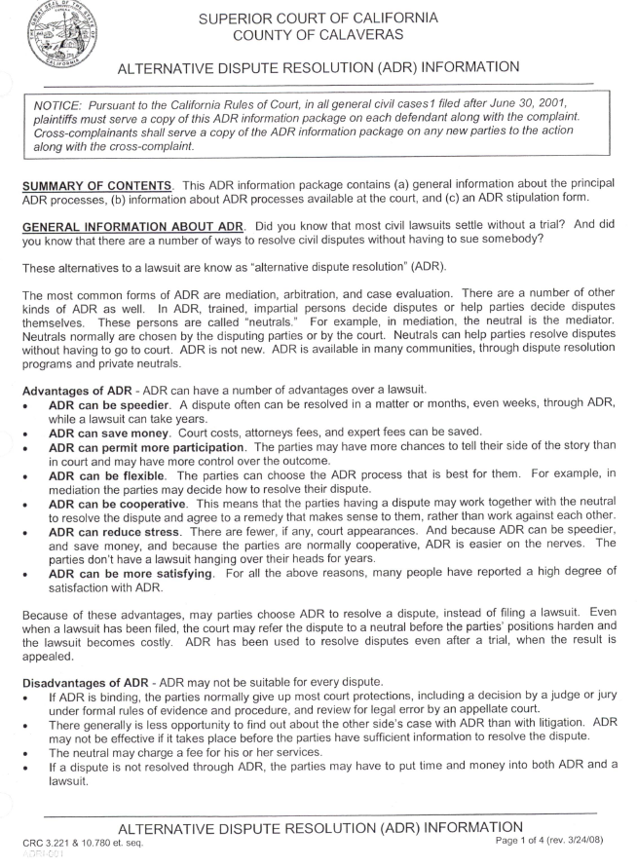
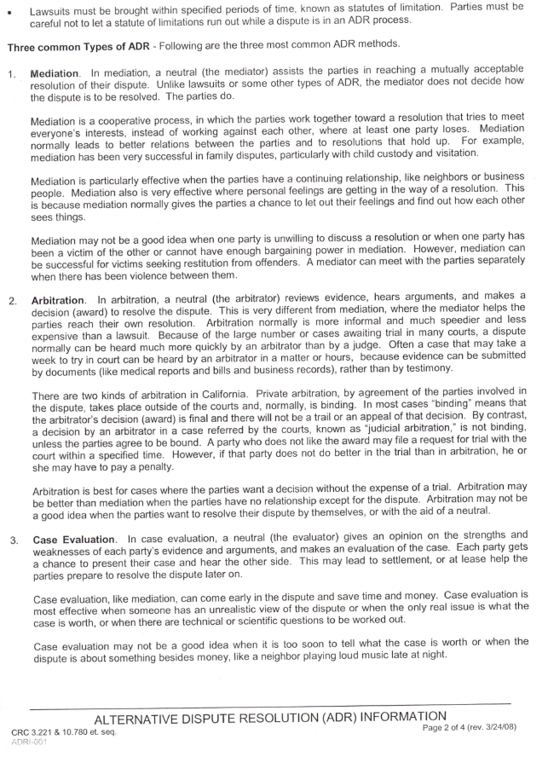

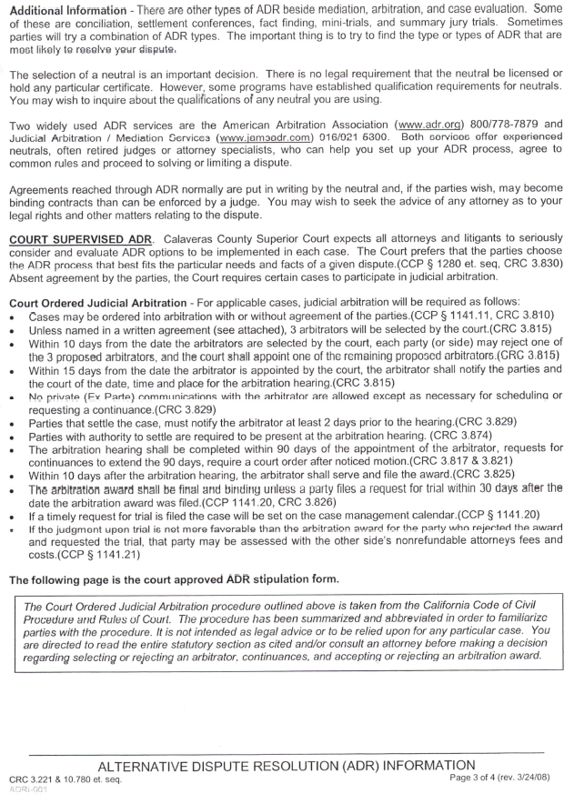

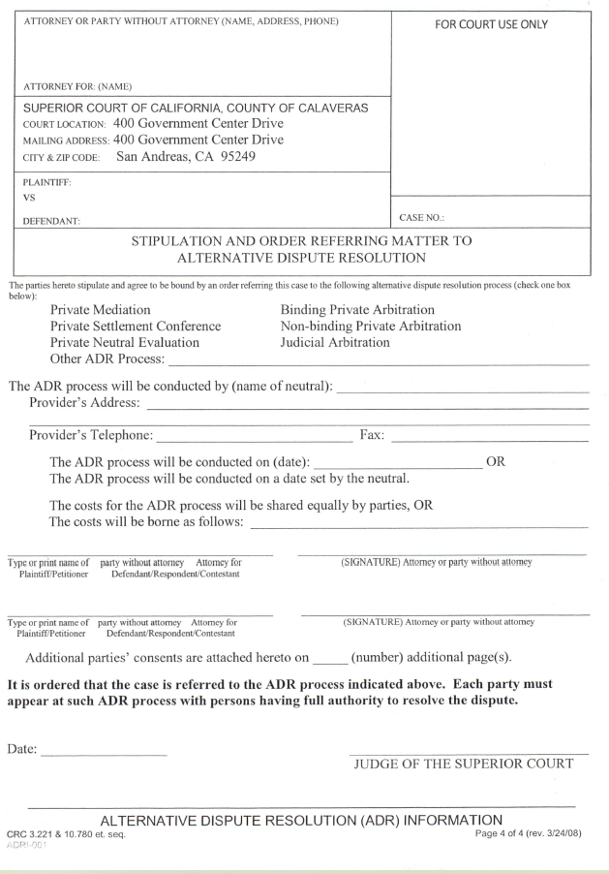

Calaveras Superior Court

THIS APPLICATION MUST BE FULLY COMPLETED
ATTORNEY OR PARTY WITHOUT ATTORNEY (NAME, ADDRESS, PHONE)  ATTORNEY FOR: (NAME) | FOR COURT USE ONLY
SUPERIOR COURT OF CALIFORNIA, COUNTY OF CALAVERAS  ADDRESS: 400 GOVERNMENT CENTER DRIVE  CITY & ZIP CODE: SAN ANDREAS, 95249-9794 | FOR COURT USE ONLY
PETITIONER/PLAINTIFF:  RESPONDENT/DEFENDANT: | FOR COURT USE ONLY
REQUESTED
HEARING DATE:__________________ TIME:__________ DEPT:_____
 | CASE NO.:
APPLICATION FOR IMMEDIATE COURT HEARING AND ORDER

I, __________________________________________, hereby declare the following is true and correct:
(Applicant’s name is printed above)

- The opposing party ◻ is ◻ is not represented by an attorney. Opposing attorney(s) or selfrepresented party’s name, address and phone number is _________________________________ ________________________________________________________________________________
________________________________________________________________________________
________________________________________________________________________________
________________________________________________________________________________

(Absent exceptional circumstances or clear statutory authority, ALL parties to this action must be given PRIOR notice of this application.)
- ◻ I provided actual notice of the hearing by speaking to the other party or attorney:

Notice was given to __________________________________ on ____/____/____ at _____ am/pm and he/she ◻ will ◻ will not appear at the hearing and ◻ does ◻ does not oppose relief sought.

Notice was given to __________________________________ on ____/____/____ at _____ am/pm and he/she ◻ will ◻ will not appear at the hearing and ◻ does ◻ does not oppose relief sought.
◻ Notice given to additional parties / attorneys listed under “Other” on page 2 of this declaration.

(If ANY party to this action has not received actual notice of this application you must check 3 below and explain why no notice was given on page 2)

- ◻ I have not provided notice of the hearing for the reasons set forth on page 2 of this declaration.

- The orders I am requesting: ________________________________________________________ _____________________________________________________________________ ◻ See page 2.

FOR COURT USE ONLY

- Set hearing as requested. ◻ Re-set hearing to _____________________________
- Request for hearing is denied. ◻ Insufficient application @ # ____________________
- Use regular noticed motion. ◻ Other : _____________________________________ ________________________________________________________________________________

Dated: ________________ _____________________________________________
- Judge / ◻ Deputy Clerk
____________________________________________________________________________________________________

APPLICATION FOR IMMEDIATE COURT HEARING AND ORDER
Page 1 of 2 (rev. 01/01/08) CRC 3.1200-1207; CRC 4.111; FC 240, 3062, 6320, 7710 & CCP 527
Form Approved for Madatory Use Form A-1

Calaveras Superior Court

THIS APPLICATION MUST BE FULLY COMPLETED

- (Continued from 3.) Facts showing why no notice should be required prior to the hearing:
_________________________________________________________________________________
_________________________________________________________________________________
_________________________________________________________________________________
_________________________________________________________________________________
_________________________________________________________________________________
_________________________________________________________________________________

- (Continued from 4.) Specify exactly what orders you are requesting: _______________________
_________________________________________________________________________________
_________________________________________________________________________________
_________________________________________________________________________________
_________________________________________________________________________________
_________________________________________________________________________________
_________________________________________________________________________________

- I ◻ have ◻ have not made prior applications for the same or similar relief. If you have, explain:
_________________________________________________________________________________
_________________________________________________________________________________
_________________________________________________________________________________
_________________________________________________________________________________
_________________________________________________________________________________

- There ◻ are ◻ are not other court cases between these parties. If so, state the name of the court, case number and the general nature of those cases: _______________________________________ _________________________________________________________________________________
_________________________________________________________________________________
_________________________________________________________________________________
_________________________________________________________________________________

- Other facts / circumstances in support of this Application: __________________________________
_________________________________________________________________________________
_________________________________________________________________________________
_________________________________________________________________________________
_________________________________________________________________________________
_________________________________________________________________________________
_________________________________________________________________________________

- ◻ Prior to the hearing, all other parties will receive a completed copy of this Application.

I have read the above completed application and personally know the above statements are true.
I declare under penalty of perjury under the laws of the State of California that the foregoing is true and correct. Executed at ______________________, California, on ______________________.

_______________________________________ _______________________________________ Printed name of declarant Signature of declarant
____________________________________________________________________________________________________

APPLICATION FOR IMMEDIATE COURT HEARING AND ORDER
Page 2 of 2 (rev. 01/01/08) CRC 3.1200-1207; CRC 4.111; FC 240, 3062, 6320, 7710 & CCP 527
Form Approved for Madatory Use Form A-1

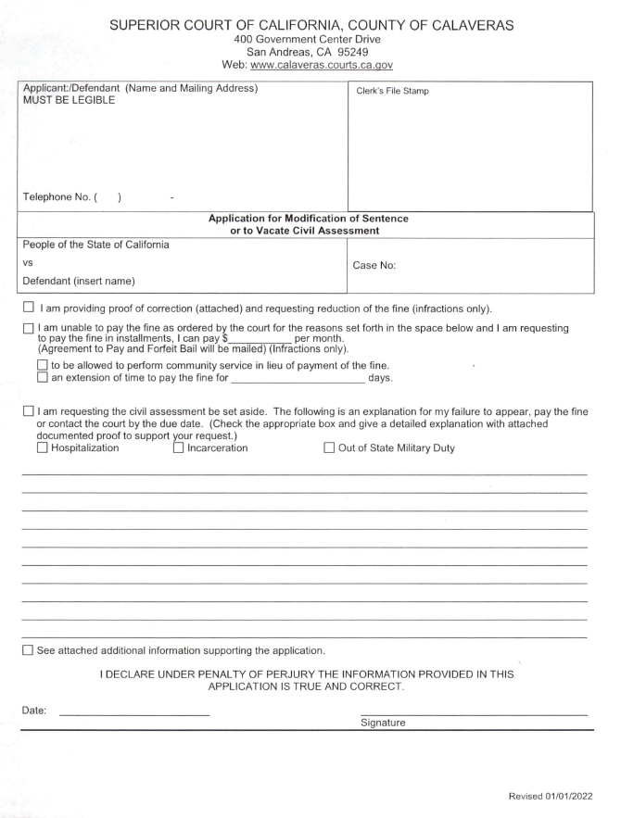

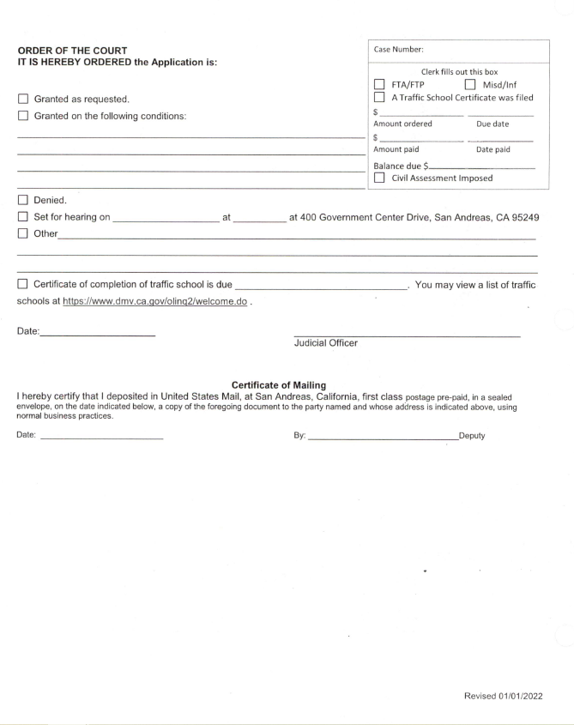
SUPERIOR COURT OF CALIFORNIA

COUNTY OF CALAVERAS

400 Government Center Drive
San Andreas, CA 95249
INFRACTIONS ONLY
DECLARATION / ABILITY TO PAY
Case Number:
Clerk fills out this box
FTA/FTP
A Traffic School Certificate was filed
Amount ordered Due date
Amount paid Date paid
Balance due $
Civil Assessment Imposed

If you have more than one case, use one form for each case.
1 . Your Information:
Name: ____________________________________________________
Street or Mailing Address: ____________________________________
City: _______________________ State: ______ Zip: ____________
Tel.:__________________________ Date of Birth: __________
E-mail (optional):
- What kind of help do you want from the court? (Check all that apply to your request)
- a. Lower the fine   b. Reduce monthly payment  c. Payment Plan | - d. Community Service g. Accept Proof of Correction  h. Set aside Civil Assessment  - e. Ask for a Court Date i. Release DMV License Hold (Abstract)  - f. Other (specify): _____________________________________

- Can you afford to pay?
Yes (Skip Section 4 and complete Sections 5, 6 and 7)
No (If you check this box, you must also fill out Sections 4, 5, 6, and 7)
- Public Benefits - Check any benefits listed below that you are receiving now.
If you do not receive benefits, go to the next question.
Medi-Cal CalFresh/WlC CalWORKs CAPI a SSI/SSP a Low-Income Veterans Pension Tribal TANF
Refugee Cash Assistance General Assistance Extended Foster Care IHSS  Other need-based help (specify):
__________________________________________________________________________________________
Important! Attach a copy of any document that proves you are getting the benefits you checked.

5. Household Income:
Monthly income $ _____________________ Number of people in household: _______________
Important! Attach a copy of any document(s) that proves the amount of gross-monthly income (before tax deductions) for your household. In Item 6, provide any details or special circumstances you want the court to consider. Please sign and date on next page

Mandatory Form DECLARATION / ABILITY TO PAY FORM Page 1 of 2
Revised 10/23/2025

Case Number: ____________________
____________________________
Applicant's Name:
- Describe your Request
Please explain the reason for your request and any details or special circumstances you want the court to consider. (Attach more pages if you need more space.)

For Court Use Only
Court's Decision
Granted as to letter(s): _________________________________________________________________
Denied as to letter(s): __________________________________________________________________
- Deadline to Pay Extended: 3 Months 6 months Other __________________________
- Fine reduced to: ________________________________________________________________________
Other Orders: ___________________________________________________________________________
___________________________________________________________________________________________________
___________________________________________________________________________________________________
___________________________________________________________________________________________________
Date: ________________________ ___________________________________________
JUDICIAL OFFICER

- Read and sign below
I declare under penalty of perjury under the laws of the State of California that the information I have provided on this form is true and correct.
Date:
Applicant signs here
Submitted
by:
Clerk Name
Certificate of Mailing
I hereby certify that I deposited in United States Mail, at San Andreas, California, first class postage pre-paid, in a sealed envelope, on the date indicated below, a copy of the foregoing document to the party named and whose address is indicated above, using normal business practices.
Date: _____________________ By: ____________________________________, Deputy
Mandatory Form DECLARATION / ABILITY TO PAY FORM Page 2 of 2
Revised 10/01/2025

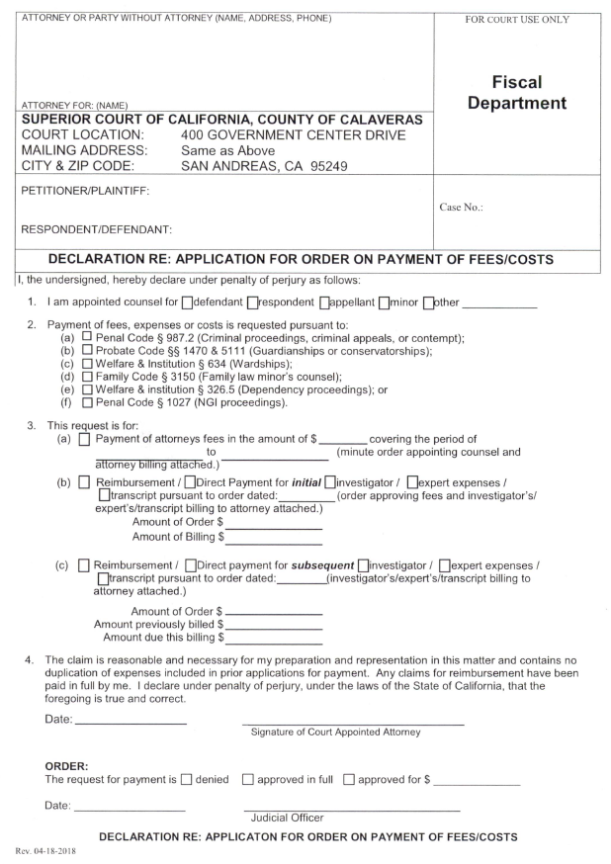

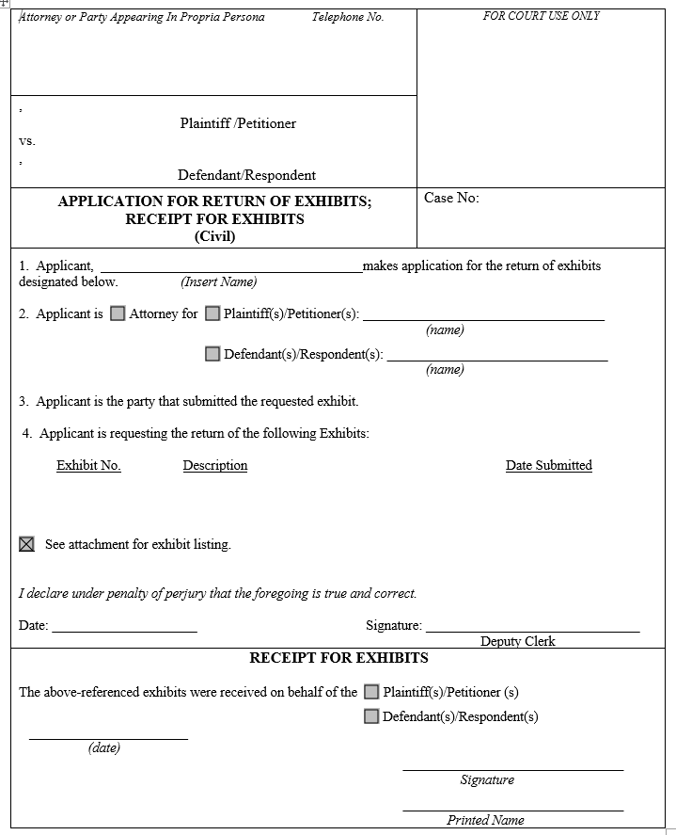
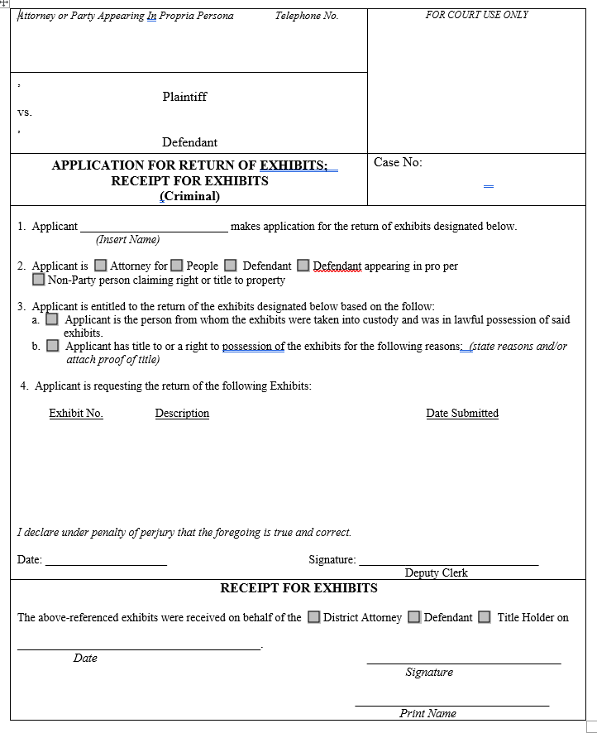
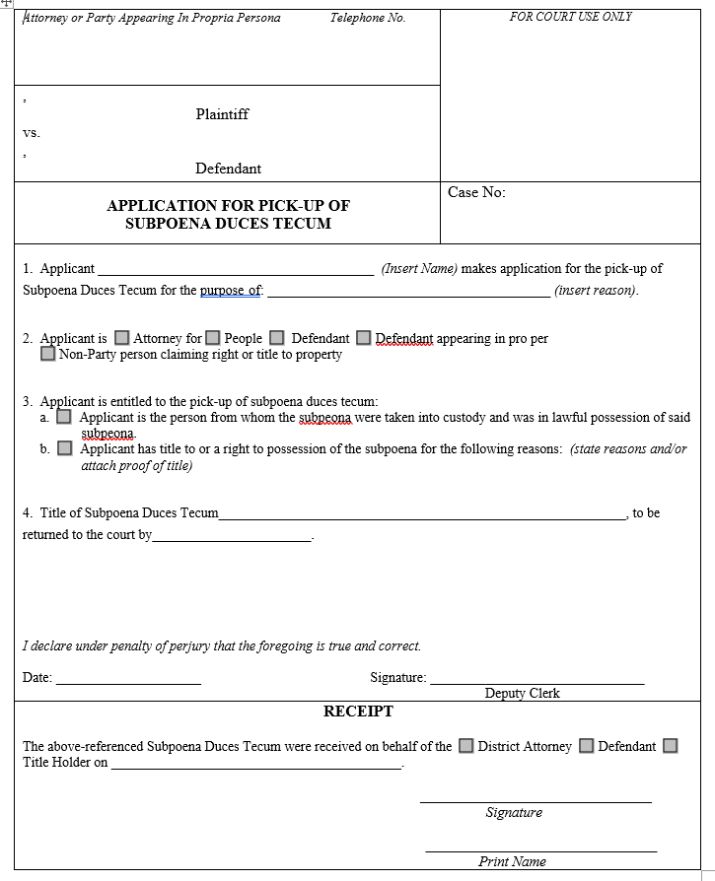

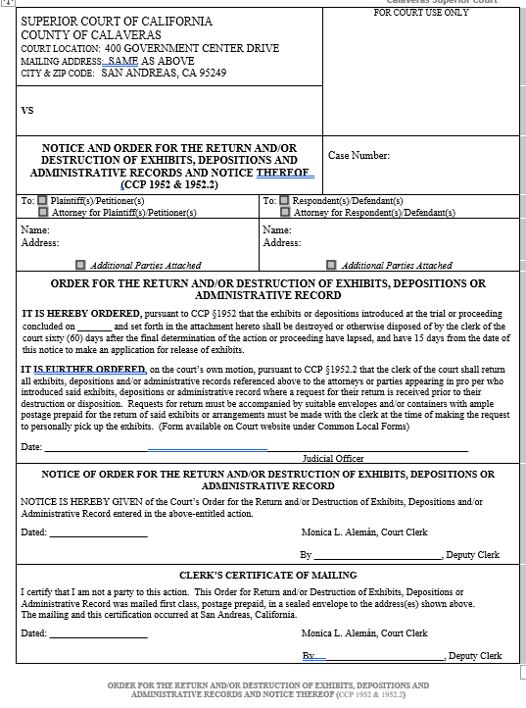

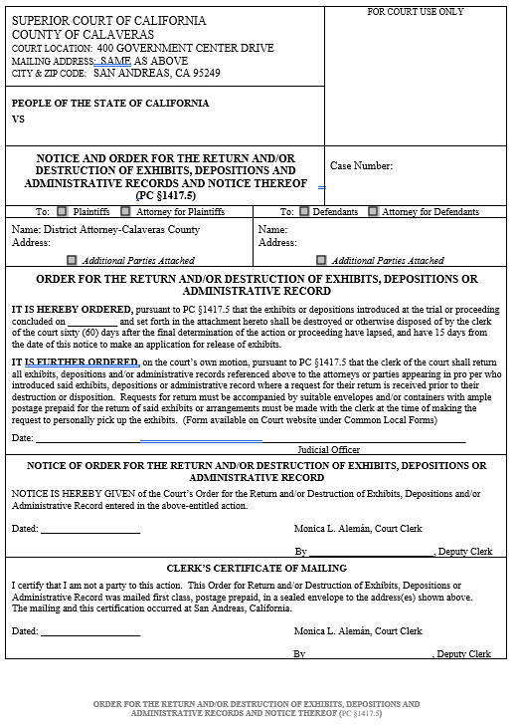

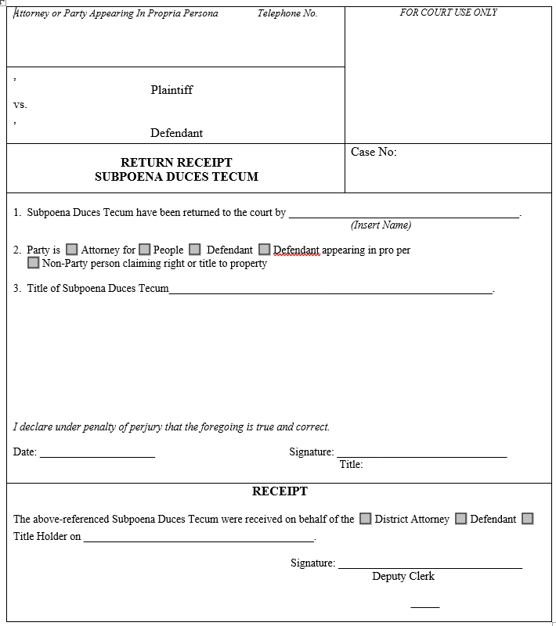

Calaveras Superior Court Juvenile Division
Counsel Certificate of Competence
Name: __________________________________________
State Bar No.: __________________________________________
Address: __________________________________________
__________________________________________
Telephone number: __________________________________________

I am an attorney-at-law licensed to practice in the State of California. I hereby certify that I meet the minimum standards for practice before a Juvenile Court set forth in California Rules of Court, Rule 5.660, and Local Rule No. 5.50 and that I have completed the minimum requirements for training, education and/or experience as set forth below.

Training and Education:
(Attach copies of MCLE certificates or other documentation of attendance)
Course Title Date Completed Hours Provider
____________________________________________________________________________
____________________________________________________________________________ ____________________________________________________________________________

Juvenile Dependency Experience:
(Necessary where counsel does not have sufficient MCLE or other training per 5.660)
No. of Date of Last Party
Case # Contested Hearings Appearance Represented
____________________________________________________________________________
____________________________________________________________________________ ____________________________________________________________________________

Dated: _______________________________
Signature

______________________________________________________________________________
JUVENILE CERTIFICATE OF COMPETENCE
(Eff. 7/1/98; As amended, eff. 1/1/08.) CRC 5.660 & LR 5.50
Form Adopted for Mandatory Use
Local Rules for the Calaveras Superior Court - Appendix A-2
Calaveras Superior Court
ATTORNEY OR PARTY WITHOUT ATTORNEY (NAME, ADDRESS, PHONE)  ATTORNEY FOR: (NAME) | FOR COURT USE ONLY
SUPERIOR COURT OF CALIFORNIA, COUNTY OF CALAVERAS  _{ADDRESS:} 400 GOVERNMENT CENTER DRIVE  _{CITY & ZIP C} ODE: SAN ANDREAS, 95249-9794 | FOR COURT USE ONLY
PETITIONER:  RESPONDENT: | FOR COURT USE ONLY
CASE MANAGEMENT  CONFERENCE DATE:____________________ __ TIME:_________ DEPT:_______ | CASE NO.:
FAMILY LAW CASE STATUS CONFERENCE STATEMENT
[ ]Telephonic Appearance Requested*
- I am(a) attorney for petitioner or respondent
  - self-represented petitioner or self-represented respondent
  - other (explain): _______________________________________________

- The other party is is not represented by an attorney. Opposing attorney or self-represented party’s name, address and telephone number is:
Name: __________________________________ Rep.: __________________________________
Add. & Phone: ___________________________________________________________________ _______________________________________________________________________________ Additional parties and representative information attached.

- This case involves the following issues and the status is (check all that apply):
Child Custody resolved by agreement court order still pending.
Child Support resolved by agreement court order still pending. Spousal Support resolved by agreement court order still pending. Division of Interest in Residence resolved by agreement court order still pending. Division of Pension resolved by agreement court order still pending. Marital Property or Debts resolved by agreement court order still pending. Additional issues information attached.

- I have met and conferred with the other party / attorney on those issues listed in paragraph “3” above and
the areas of agreement / disagreement on the pending issues are:
_______________________________________________________________________________
_______________________________________________________________________________
_______________________________________________________________________________ Explanation of additional issues attached.

- Disclosures and Discovery –
I served a preliminary declaration of disclosure (FC § 2104; form FL140) ____/____/____ I served a final declaration of disclosure (FC § 2105; form FL140) ____/____/____ or
A stipulation waiving final disclosures was filed (FC § 2105; form FL144) ____/____/____ The following discovery remains to be completed and it is expected to be completed on:
_______________________________________________________________________________________________
_______________________________________________________________________________

Additional discovery information attached.

FAMILY LAW CASE STATUS CONFERENCE STATEMENT
Local Rules 5.9. Form Approved for Optional Use Form A-3 (Eff. 7/1/02; rev 1/1/14)

Calaveras Superior Court

* For telephone appearances you must schedule at least 5 days in advance with CourtCall at 888/88-COURT.
- Trial Readiness – This case is expected to take ______ days / hours of trial to complete. The following pretrial motions are anticipated pending and shall be heard on or about:
_________________________________________________________________________________
_________________________________________________________________________________
_________________________________________________________________________________
_________________________________________________________________________________ This case will be ready for trial on ____________

- Statement Prepared By:
This Statement was prepared by Petitioner Respondent and Submitted Jointly or Individually.

This statement accurately reflects the present status of the case.

Respectfully submitted,
Dated: ________________ _______________________________________
Attorney for or self-represented
Petitioner Respondent

(For jointly submitted statements only.)

This Statement accurately reflects the present status of the case.

Respectfully submitted,
Dated: ________________ _______________________________________
Attorney for or self-represented
Petitioner Respondent
8. Additional Pages - There are ______ pages attached to this Statement.

Proof of Service

I declare: I am over the age of 18, not a party to this action, and I work/reside in the county where the mailing of this document took place. My address is listed at the top of the first page or below
____________________________________________________________________________________________
________________________________________________________________________

On the date below I served a completed copy of this document on those persons listed at paragraph “2” above by enclosing the document in properly addressed and postage prepaid envelopes and depositing the sealed envelope with the U.S. Postal Service placing the envelope for collection and mailing in a location within the business where mail is regularly and ordinarily deposited with the U.S. Postal Service on the same day of deposit.

I declare under penalty of perjury under the laws of the State of California that the foregoing is true and correct.

Date: __________________ Signature: __________________________________________

Print Name: _________________________________________

FAMILY LAW CASE STATUS CONFERENCE STATEMENT
Local Rules 5.9. Form Approved for Optional Use Form A-3 (Eff. 7/1/02; rev 1/1/14)

ATTORNEY OR PARTY WITHOUT ATTORNEY (Name, State Bar Number and Address)  TELEPHONE NO.: EMAIL:  ATTORNEY FOR (NAME): | CLERK DATE STAMPED RECEIVED
CALAVERAS COUNTY SUPERIOR COURT
400 GOVERNMENT CENTER DRIVE
SAN ANDREAS, CA 95249
(209) 754-9800
PLAINTIFF/PETITIONER:  DEFENDANT/RESPONDENT: | HEARING DATE:
INTERPRETER REQUEST FORM | CASE NUMBER:
IMPORTANT: Interpreters will not always be available for all hearings or in all languages. See instructions on the reverse of this form for more information.
- I (name): am a party in the above named case. I am the (check one item below):
□Plaintiff/Petitioner □Defendant/Respondent □Other (describe): __________________________________
- I need an interpreter for (check all that apply) □me □ a witness (describe): ____________________________
- The language(s) in which I need an interpreter are □ Spanish □ Vietnamese □ Mandarin □ Cantonese
  - Hmong □ Other (list all): _______________________________________ 4. The court hearing or proceeding for which I need an interpreter is scheduled for:
(date): ______________________at (time): _________________in Courtroom .
  - No date is set yet.
  - I don’t know the date of the hearing or proceeding.
5. Type of case, if known (check one):
 Criminal |  Traffic |  Civil Harassment
 Juvenile |  Unlawful Detainer |  Guardianship
 Family Law |  Termination of Parental Rights |  Conservatorship
 Other Civil |  Domestic Violence |  Elder or dependent Abuse (not Involving
 Child Support |  Don’t know/not sure | physical abuse)
To avoid the risk that your hearing will have to be postponed, please submit this form a minimum of two weeks in advance when possible.
Date: _____________ ________________________________________
Signature

[New-01/01/2018] INTERPRETER REQUEST FORM
Approved for optional use www.calaveras.courts.ca.gov
Form A-4
Calaveras Superior Court

INSTRUCTIONS

- Court proceedings are conducted in English. If a party or a witness does not speak English well, he or she may need an interpreter to testify, to speak to the judge, and to understand what others are saying in the proceeding. Certified and registered court interpreters are specifically trained to interpret in court proceedings. If you need language assistance, you should ask the court if it can provide a court interpreter by filling out this form.

- The Calaveras Court provides interpreting services to all trial court proceedings in criminal, traffic, and juvenile matters.

- Courts are not always able to provide or pay for an interpreter in every language or in every civil case. The Legislature has set priorities for civil cases which courts with limited funds are to try to provide court interpreters. The first priority is to try to provide interpreters in the following kinds of cases:
  - Domestic violence cases,
  - Family law cases in which there is a domestic violence issue,
  - Elder or dependent adult physical abuse cases, and
  - Unlawful detainer or eviction cases.
Even in those cases, interpreters will not always be available for all hearings or in all languages.

- Courts may be able to provide interpreters in some languages in some other civil cases. The Legislature has set priorities in these cases also, providing that the court should try to provide interpreters for cases in the following order: e. Actions to terminate parental rights,
  - Actions relating to conservatorships or guardianships,
  - Actions for child custody or visitation,
  - Elder abuse cases and dependant adult abuse cases that do not involve domestic violence,
  - Actions relating to family law other than those relating to domestic violence or child custody or visitation, and j. All other civil actions, including small claims cases.
In these types of cases, preference will be given to parties with financial need who have qualified for a fee waiver, so if you need a court interpreter and need financial assistance, you should apply for a fee waiver if you do not already have one. To do so, complete and file a Request to Waive Court Fees (Civil Actions) (form FW-001). You should note in item 7 of this form whether you have a fee waiver already, have applied for one, or do not intend to apply for one.

- If your case falls within one of the categories of cases listed in paragraphs 2 or 3 above, and you would benefit from having an interpreter during your court proceedings, you should use this form to request a court interpreter. Complete the first page and file it with the court. The Request for Interpreter form should be submitted 15 days prior to your court hearing date.

- If the court is unable to provide an interpreter, you may bring a person who can speak English with you to act as an interpreter at the proceeding. You may ask a friend or relative (it should be an adult) to act as an interpreter. It must be someone who can understand, speak, and read both your language and English. The court will need to make sure that person is qualified to interpret for you or the witness before the proceeding begins and will require the person to take an oath, swearing to interpret as completely and accurately as possible. If you are going to use a noncertified court interpreter, you should give him or her a copy of the form Foreign Language Interpreter's Duties-Civil and Small Claims (form INT-200), which is available on the California Courts website at www.courts.ca.gov/documents/int200.pdf.
REQUEST FOR COURT INTERPRETER
Optional Form
Effective 1/1/2018 Form A-4 Calaveras Superior Court

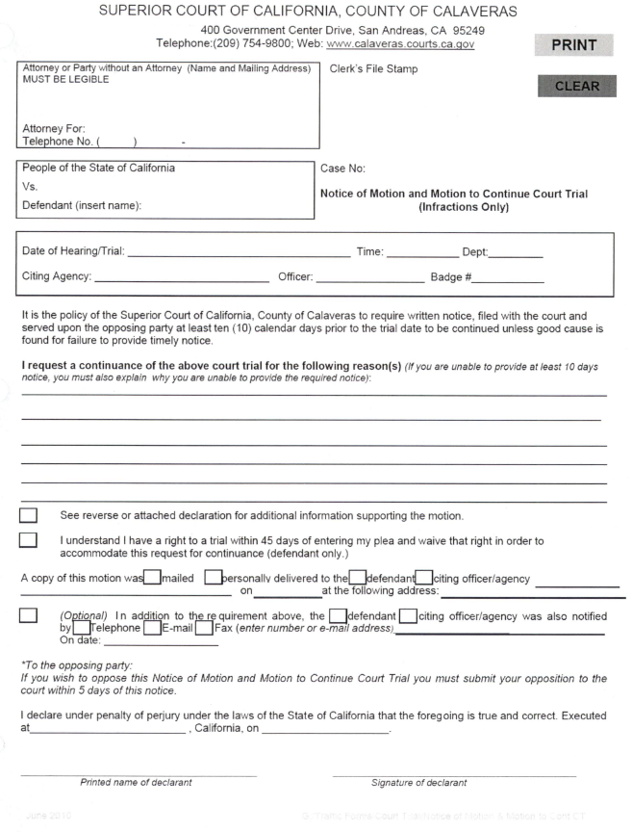

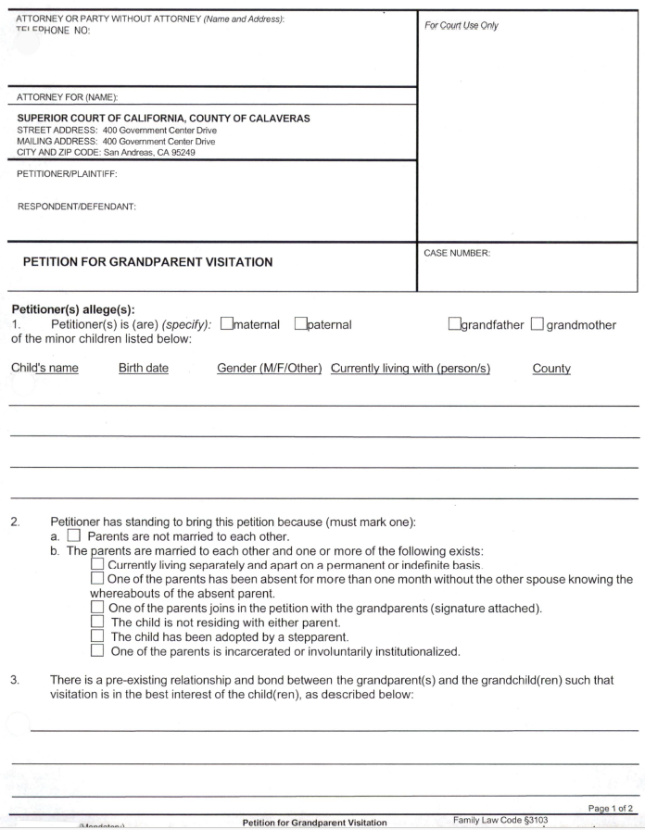

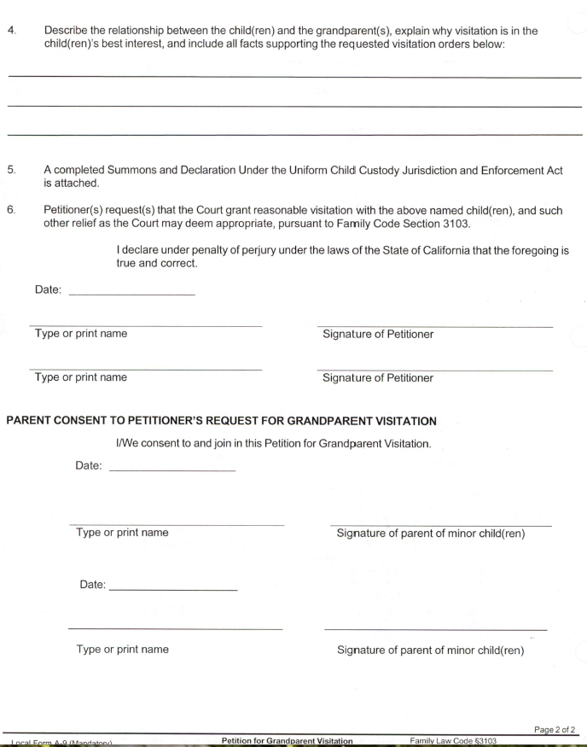

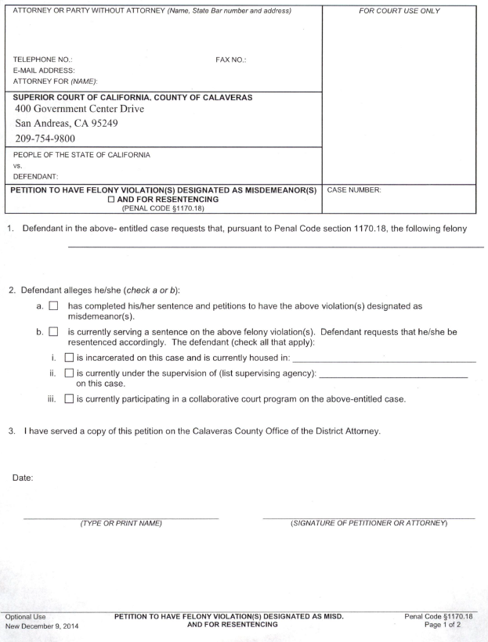

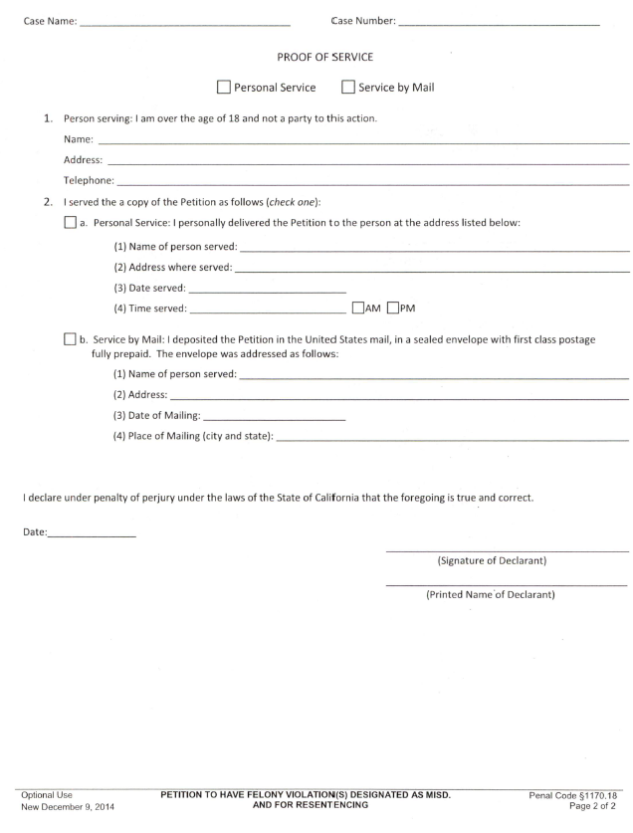

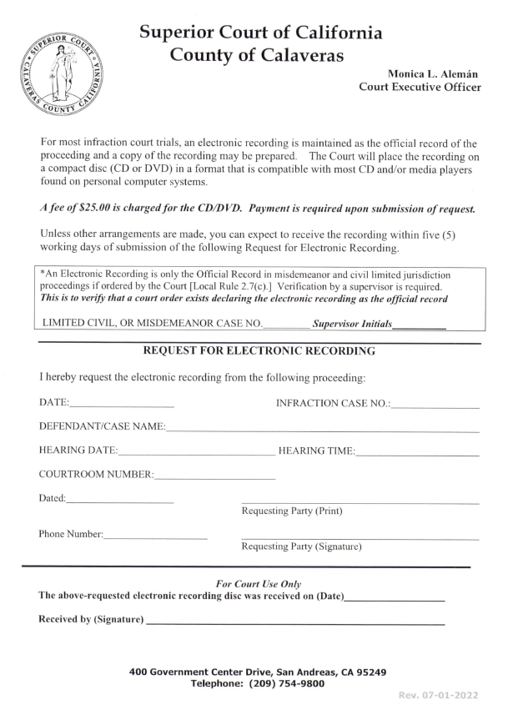

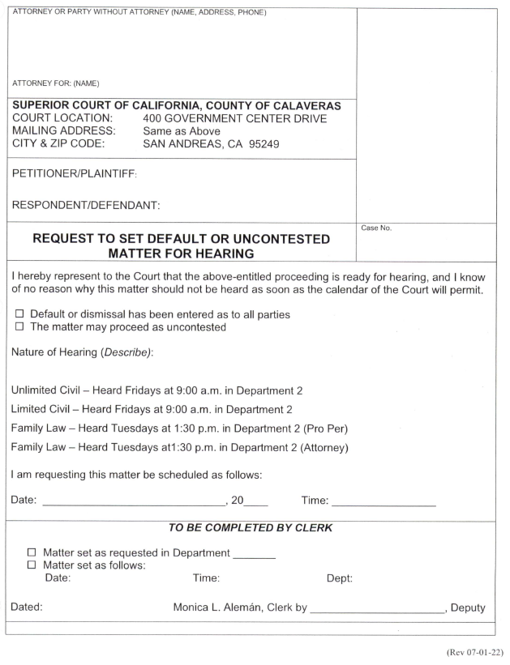
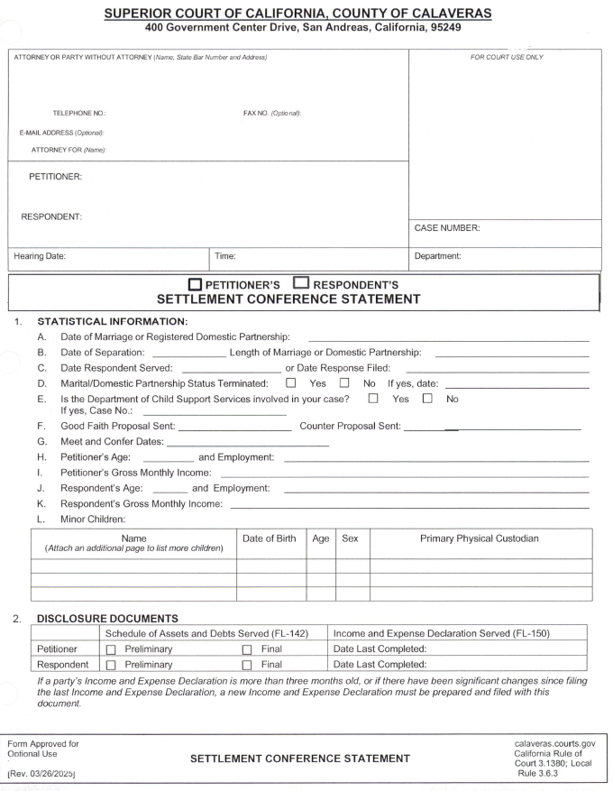

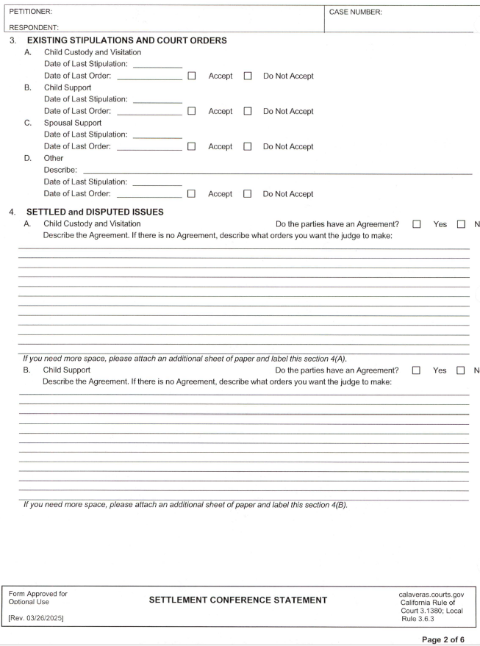

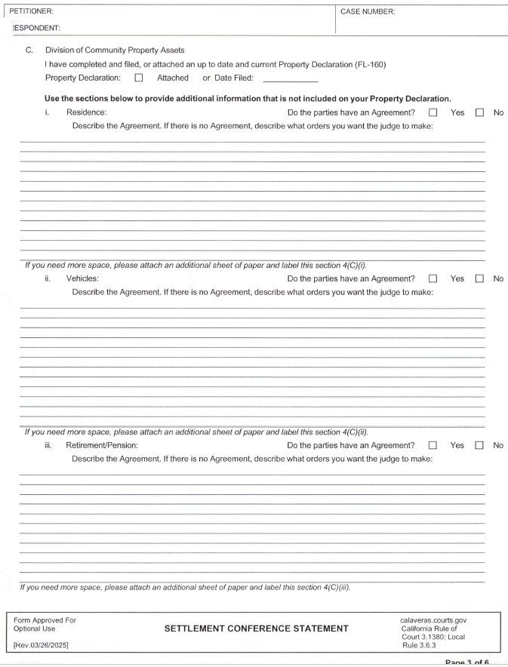

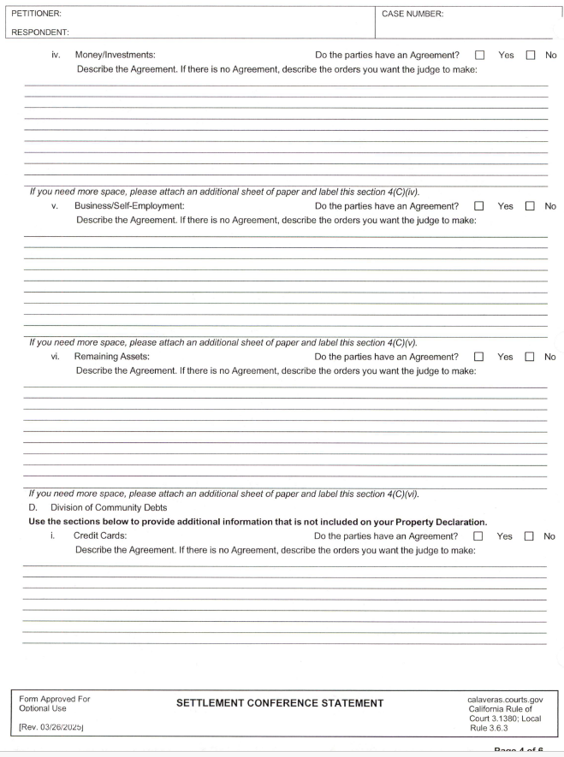

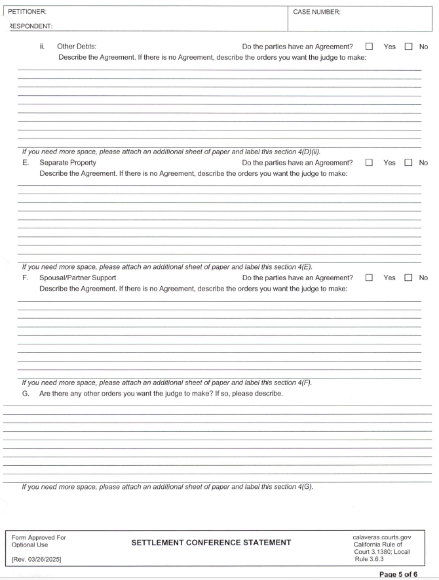
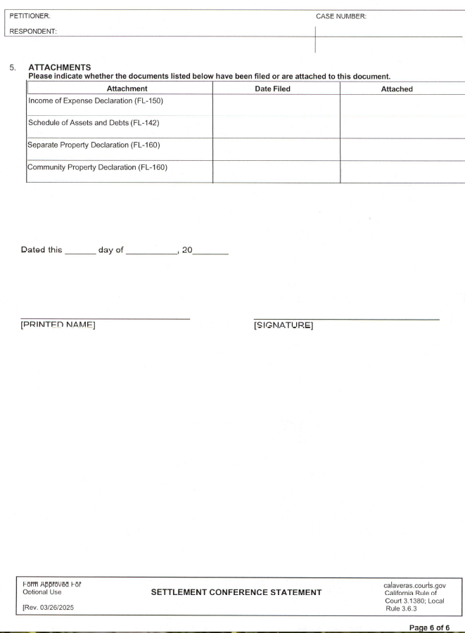

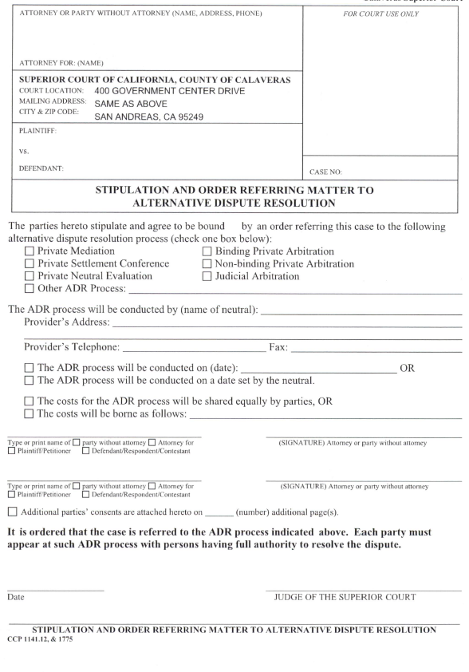
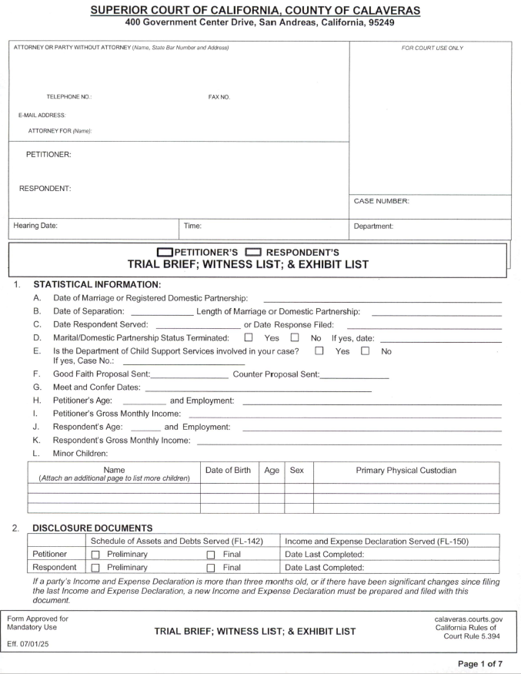

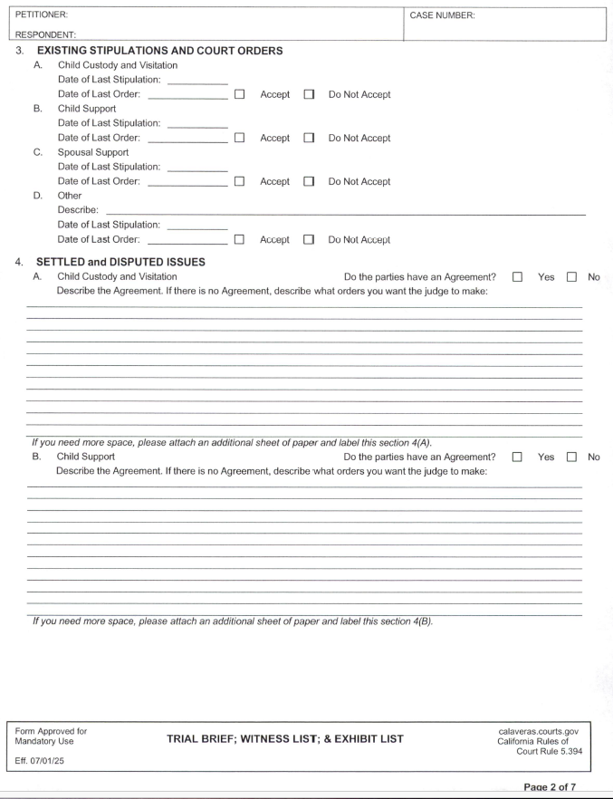

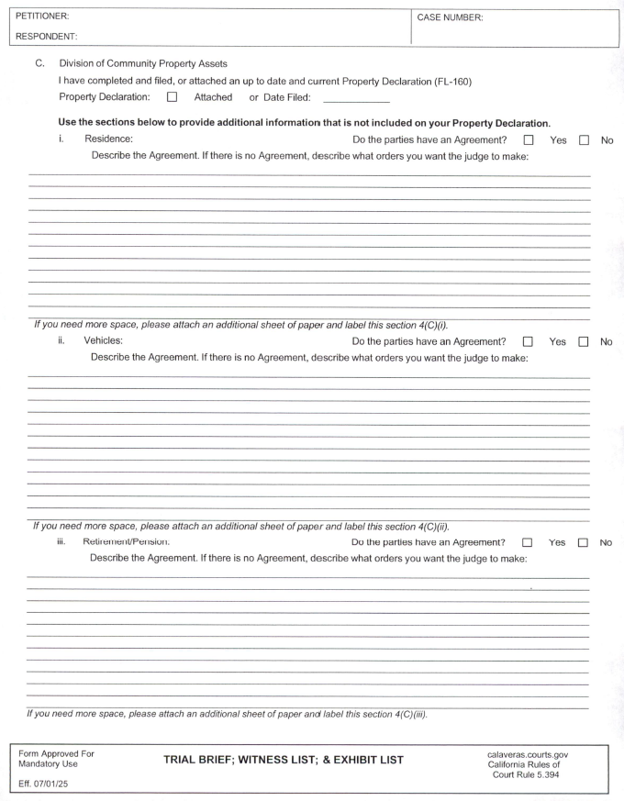

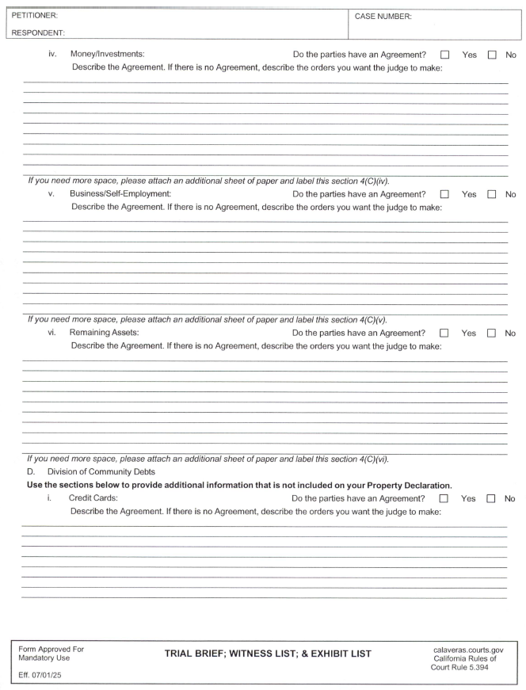
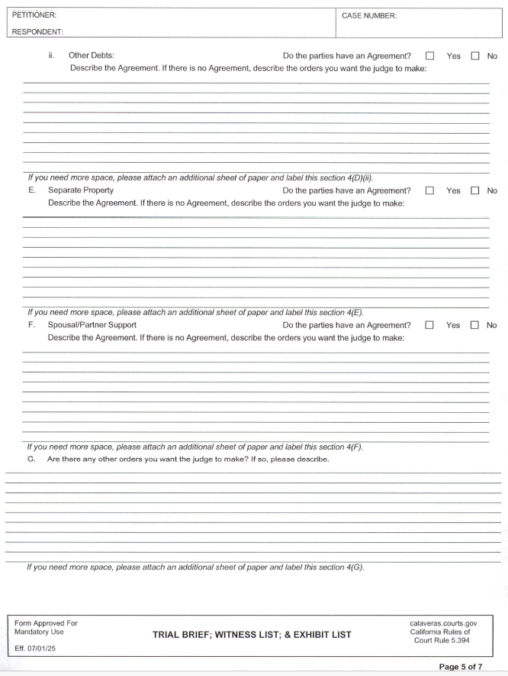

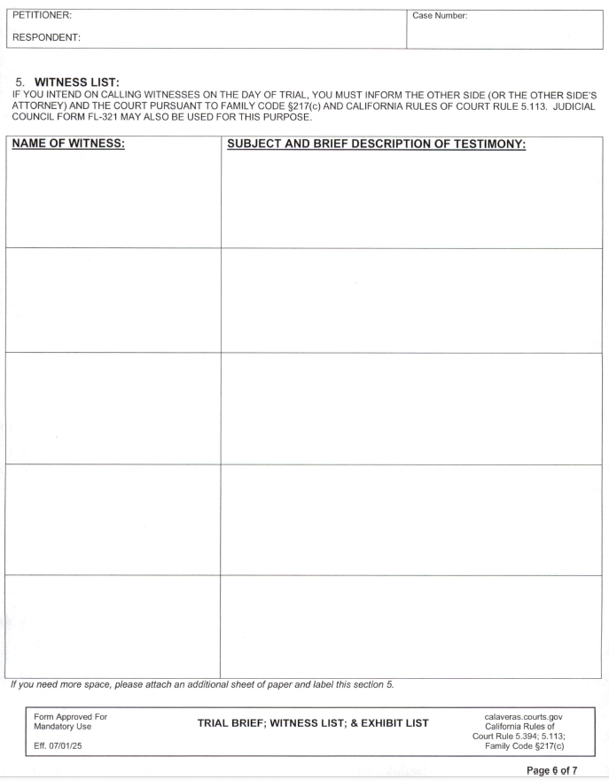

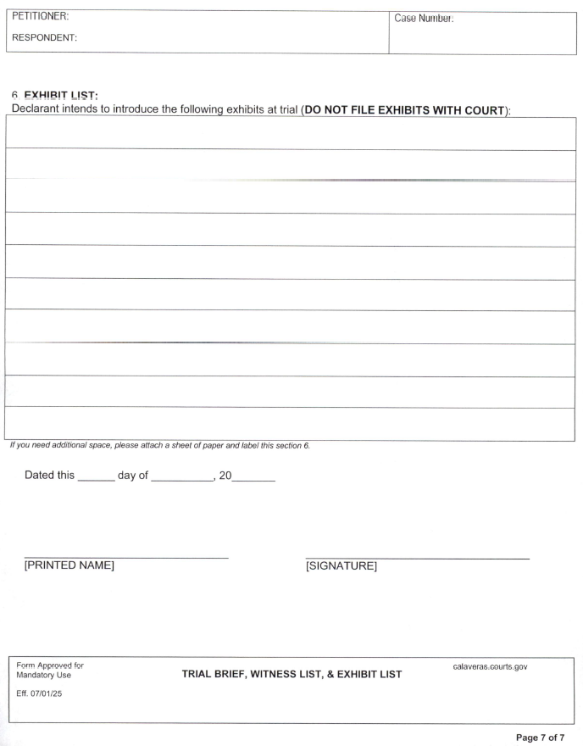

SUPERIOR COURT OF THE STATE OF CALIFORNIA, COUNTY OF CALAVERAS

Administrative Matters ......................................................................................10 ....................................................................... .58
Amendment, Addition or Repeal of these Rules - Sanctions for Failure to
Comply with Rules............................................................................................ 1.7 ....................................................................... 1
Adoption of Court Appointed Special Advocate Program.…………………....5.54.1 ………………………………………….44
Appearance for Another Attorney .......................................................................2.9 .....................................................................6
Appellate Department Management ................................................................... 8.1 .....................................................................54
Appellate Rules ...................................................................................................8 ........................................................................ 54
Application for Appointment of Guardian Ad Litem.........................................7.2.1 .................................................................. 50
Application for Waiver of Court Fees and Costs ................................................2.3 ....................................................................... 3
Appointment of Counsel in Juvenile Dependency Proceedings ......................... 5.50 ...................................................................40
Appointment of Counsel Pursuant to Family Code §3150 .................................5.10 ................................................................... 34
Appointment of Elisor………………………………………………………….2.17…………………………………………….11
At Issue Memorandum Abolished......................................................................3.4.9 .................................................................. 19
Attorney Conduct.................................................................................................2.16…………………………………………….11
Attorney’s Fees on Default Judgments ..............................................................3.3.3 .................................................................. 15
Audio/Visual and Other Equipment for Demonstrative Evidence ....................2.11 ..................................................................... 7
Authorization to Administer Psychotropic Medications .....................................5.52 ................................................................... 43
Briefing Procedures ...........................................................................................8.3 ..................................................................... 54
Bulky and Hazardous Exhibits ..........................................................................2.12 ..................................................................... 7
Calendar Priority.................................................................................................5.54.6………………………………………….46
Calendaring Requests ........................................................................................2.8 ....................................................................... 6
Case Management Conference ...........................................................................3.4.5 .................................................................. 18
Chapter 9 Reserved .............................................................................................9.........................................................................58
Child Custody Evaluations ................................................................................5.12 ...................................................................36
Child Custody Mediation ..................................................................................5.11 ...................................................................35
Citation of Rules ...............................................................................................1.2 ....................................................................... 1
Civil Delay Reduction Rules ............................................................................3.4 ..................................................................... 16
Civil Mediation Program ..................................................................................3.9…................................................................... 22
Civil Rules ........................................................................................................3 ........................................................................ 13
Claims of Minors and Incompetent Persons .....................................................7.2 ..................................................................... 50
Clerk's Transcript on Appeal ............................................................................8.3 ..................................................................... 54
Compensation for Guardians, Conservators, Trustees and their Counsel,
and for Counsel for a Conservatee or Ward .....................................................7.1 ..................................................................... 50
Compensation of Appointed Counsel ...............................................................2.10 ..................................................................... 7
Compromise of Claims and Attorney’s Fees ....................................................7.2.2 ..................................................................51
Construction and Application of Rules .............................................................1.5 ...................................................................... 1
Continuance of Infraction Trials……………………………………………….4.10……………………………………………27
Continuances .....................................................................................................4.2 .....................................................................23
Continuances on Short Cause Law and Motion and Order to
Show Cause Calendar .......................................................................................3.3.5 ................................................................. 16
Coordination of Personal Conduct Orders ........................................................2.13 .................................................................. 8
Court Appointed Special Advocate Program………………………………….5.54……………………………………………44
Court Executive Officer ..................................................................................10.3 .................................................................... 59
Court Interpreters………………………………………………………………2.6……………………………………………...5
Court Reporter Availability ............................................................................ .2.7 ..................................................................... 6
Criminal Rules .................................................................................................4 ....................................................................... 23
Cross Complaints .............................................................................................3.4.4 ................................................................. 17
Default Judgments by Affidavit .......................................................................3.3.2 ................................................................. 16
Definition of General Civil Case ......................................................................3.4.2 ................................................................. 17
Demand for Jury Trial ......................................................................................3.4.7 ................................................................. 18
Differentiation of Cases to Achieve Goals ........................................................3.4.6 ................................................................ 18
Discovery .........................................................................................................4.5 ..................................................................... 23
Dismissal of Domestic Violence Orders or Actions………………………….5.14…………………………………………….37
Distribution of CASA Reports………………………………………………...5.54.9……………………….…….…………...46
Distribution of CASA Reports………………………………………………...5.54.10…………………………………………47
Domestic Violence Restraining Order, Remote Appearance………………….5.16……………………………………………38
Each Party to be Prepared…………………………………………………….3.6.2…………..………………………………...19
Electronic Filing ………………………………………………………….…2.15……………………………….………………10
Effect of Rules ..................................................................................................1.4 ......................................................................... 1
Effective Date of Rules .....................................................................................1.3 ......................................................................... 1
Evaluations, Child Custody ..............................................................................5.12 ...................................................................... 36
Ex Parte Applications .......................................................................................3.1 ....................................................................... 13
Ex Parte or Informal Communication with the Court ......................................2.4 ......................................................................... 4
Exhibits……………………………………………………………………….4.13………………………………………. ….….27
Exchange of Info., Juvenile, Probate, Family Courts ..................................... 5.53 .......................................................................43
Facsimile Filings ............................................................................................. 2.2 ..........................................................................3
Failure to Appear ............................................................................................ 3.6.5 ......................................................................20
Family Law and Juvenile Rules .......................................................................... 5 ........................................................................28
Family Law Case Flow Program ...................................................................... 5.9 ........................................................................33
Family Law Facilitator .................................................................................... 5.13 .......................................................................37
Fees for Investigators and Experts ………....................................................... 4.8 ........................................................................24
Filing and Format of Documents ..................................................................... 2.1 ..........................................................................3
Filing Family Law Motions with the Court ..................................................... 5.4 ....................................................................... 30
Filing of Appeal, Briefing and Hearing Dates ................................................. 8.2 ....................................................................... 54
Filing the At-Issue Memorandum ................................................................... 5.8.1 ................................................................ ….32
General Rules ..................................................................................................... 2 .......................................................................... 3
Gun Violence Restraining Orders…………………………………………….6.1……………….………………….…………….48
Hearings on Family Law Motions ................................................................... 5.6 ........................................................................ 31
Initial Contact ................................................................................................. 3.4.3 ...................................................................... 17
Judicial Arbitration .......................................................................................... 3.5 ........................................................................ 19
Judicial Vacation Day Defined ....................................................................... 10.2 ....................................................................... 59
Juvenile Facsimile Filings .............................................................................. 5.51 ........................................................................43
Juvenile Probate and Family Courts Exchange of Information ...................... 5.53 ........................................................................43
Juvenile Rules ..................................................................................................... 5 ........................................................................ 40
Lack of Appearance ........................................................................................ 3.3.6 ...................................................................... 16
Law and Motion .............................................................................................. 3.3 ......................................................................... 14
Mandatory Settlement and Trial Setting Conference ..................................... 5.8.2 ...................................................................... 32
Mandatory Trial Readiness Conference……………………….…………… 4.12…………………………….….………………27
Matters Heard .................................................................................................. 5.1 .........................................................................28
Misdemeanors and Infractions………………………………………………...4.11………………………………………………27
Motion to be Relieved as Counsel .................................................................. 3.3.1 ...................................................................... 15
Motions ........................................................................................................... 3.4.8 ...................................................................... 18
Motions for Bail Modifications or Release on Own Recognizance ................. 4.6 ....................................................................... 23
Official Reporting Services .............................................................................. 2.7 ......................................................................... 6
Orders After Hearing ...................................................................................... 3.3.4 ...................................................................... 15
Orders on Motions and Stipulations ................................................................. 5.7 ....................................................................... 32
Participation in Good Faith ............................................................................. 3.6.4 ...................................................................... 20
Plea Bargaining ................................................................................................ 4.4 ........................................................................ 23
Photographing, Recording, or Broadcasting in Court…………….…….……2.14………………………….……………………...9
Pleas at the Time of Trial ................................................................................ 4.3 ......................................................................... 23
Pre-Hearing Meet and Confer/Exchange of Documents………………………5.5………………………….……………………31
Preliminary Rules .............................................................................................. 1 .......................................................................... .1
Prerogative Writs ............................................................................................ 8.6 ......................................................................... 56
Presiding Judge ............................................................................................... 10.1 ....................................................................... 59
Probate Rules ................................................................................................... 7.1 ........................................................................ 50
Probate Petition and Motion Calendar…………………………….……….….7.3………………………………………………. 53
Proof Of Service of Summons.......................................................................... 3.2 ........................................................................ 14
Real Property Bonds in Lieu of Cash Bail ....................................................... 4.9 ........................................................................ 25
Record in Appeals to the Appellate Department………… …………………8.4………………… ………………………….55
Release of Information to the Special Advocate……………………………5.54.4………………………….………….………...45
Release on Own Recognizance/Bail ............................................................... .4.6 ........................................................................ 23
Remote Appearance………………………………………………………….3.8…………………………………………………21
Requirement of Settlement Conference ........................................................ 3.6.1 ........................................................................ 19
Right to Appear…………………………………………………………….5.54.8………………………………………………..46
Right to Timely Notice…………………………………………………….5.54.5………………………………….……………..46
Sanctions ...................................................................................................... 3.4.10 ....................................................................... 19
Scope and Policy ........................................................................................... 3.4.1 ........................................................................ 16
Scope of Rules ................................................................................................. 1.1 .......................................................................... 1
Sealed/Confidential Records ........................................................................... 2.5 .......................................................................... 5
Service of Notice/Pleadings of Family Law and Motion Hearings ................ 5.3 ......................................................................... 30
Setting Family Law Motion Hearings ............................................................. 5.2 ......................................................................... 29
Settlement Conference .................................................................................. 3.6.1 ........................................................................ 19
Settlement Conference Statement ................................................................. 3.6.3 ........................................................................ 20
Special Advocates………………………………………………………… .5.54.3……………………………………..……….. 44
State Rules and Corresponding Local Rules ....................................................... 1.6 ....................................................................... 1
Telephonic Appearances for Child Support……………………………………5.15……………………………………………....37
Temporary Restraining Orders ............................................................................ 3.1 ..................................................................... 13
Tentative Rulings ................................................................................................ 3.3.7 ................................................................... 15
The CASA………………………………………………………………….….5.54.2……………………………………………..44
Traffic Infractions - Trial by Declaration ............................................................ 4.7 ......................................................................24
Trial .................................................................................................................... 5.8 ....................................................................... 32
Trial Settlement Conference ............................................................................... 3.6 ...................................................................... 19
Trustee ................................................................................................................ 7.1 ...................................................................... 50
Unlawful Detainer Trials………………………………………………………..3.7.1…………………….………………………21
Unlawful Detainer Settings ................................................................................ 3.7 ....................................................................... 21
Visitation Through Dependency………………………………………………..5.54.7……………………………………………46
Withdrawal of Counsel ...................................................................................... 3.3.1 .................................................................... 15
Withdrawal of Funds ......................................................................................... 7.2.3 .................................................................... 52
Witness List ....................................................................................................... 4.1 ....................................................................... 23

“bulky” objects are those exceeding 1 cubic foot in volume.
“heavy” objects are those exceeding 3 lbs. by weight.
All controlled substances listed in Health & Safety Code Sections 11054, 11055, 11056, 11057, and 11058 are considered to be hazardous waste material.

